**The Growth and Evolution of Bureaucracy in the Department of Defense**

**Since the Goldwater-Nichols Act of 1986**

Zachary Duane Hofstra

School of Complex Adaptive Systems

Arizona State University

CAS 593: Master of Science in Complex Systems Science

Dr. Deryc Painter

7 December 2025

The views expressed in this report are those of the authors and do not necessarily reflect the official policy or position of the Department of the Army, the Department of War, or the U.S. Government.

# Abstract

This study examines the evolution of bureaucratic structures within the United States Department of Defense[1] (DoD) following the Goldwater-Nichols Act (GNA) of 1986. Using personnel data from 1987-2024, this research applies linear regression analysis to track changes in rank distributions, organizational hierarchies, and administrative growth across military services. Drawing on Max Weber's theory of bureaucratic rationalization (Kim, 2023) and Robert Michels' iron law of oligarchy (Michels, 1962), this study demonstrates that the Goldwater-Nichols Act (GNA) intentionally triggered a regime change in DoD organizational dynamics that caused upward bureaucratic drift. Results show statistically significant growth in senior leadership positions relative to junior personnel, expansion of staff and administrative roles, and proliferation of DoD-wide policies. The primary long-term drivers for the upwards bureaucratic drift are identified as the number General Officers and Flag Officers (GOFO), the number of Presidentially Appointed-Senate confirmed (PAS) positions, and Freedom of Information Act response times as a proxy for organizational decision speeds. Short term influences are DoD policy volume and any officer that is not a GOFO. GNA was intended to produce a phase shift from service-centric to a more efficient joint-centric structure (Goldwater-Nichols Act, 1986); however bureaucratic processes characterized by hysteresis and self-reinforcing feedback mechanisms continued and grew. Endogenous and exogenous factors were considered for causal analysis as the DoD is strongly influenced by external policies and politics. Policy implications suggest that attempts to transform bureaucratic organizations may be constrained by systemic forces. Path dependence arises from availability and instant recallability of information with the advent of automations and locks out innovation and perpetuates the continuation of the hierarchical bureaucracy.

*Keywords:* [bureaucracy, Goldwater-Nichols, Department of Defense, Department of War, organizational growth, DoW, Department of War, Weber, Michels, span of control]

# Table of Contents

Abstract 2

Table of Contents 4

Chapter 1: Introduction 6

Background and Context 7

Problem Statement 9

Research Questions 9

Significance of the Study 10

Chapter 2: Literature Review 11

Chapter 3: Theoretical Framework 15

Conceptual Model 17

Chapter 4: Methodology 18

Research Design 20

Data Sources 21

Dimensions of Analysis 21

Chapter 5: Results 24

Force Structure 24

Bureaucratic Speed 27

Organizational Complexity 28

Policy Complexity 29

Political Control 30

Gross Domestic Product Growth 31

Significant Conflict 32

Combined Variable Analysis and Modeling 33

Chapter 6: Discussion 42

Theoretical Implications 44

Limitations 45

Chapter 7: Conclusions and Recommendations 48

Summary of Findings 48

Policy Recommendations 49

Future Research 49

References 51

Appendix A 56

Data Tables and Personnel Trends 56

Sparse VAR charts 56

Pairwise Granger Causality Charts 57

Vector AutoRegression Charts 59

VECM Johansen Test 61

Vector Error Correction Model Charts 62

# Chapter 1: Introduction

The word “bureau’s” etymology goes back 800 years from a French term describing a heavy woolen covering for a desk, eventually describing the desk, and finally encompassing the whole office. A heavy woolen covering is still an apt metaphor for the stifling rule of bureaucracy which the French defined as “rule from the desk.” Max Weber argued the inevitability of bureaucracy in all scaling organizations (Weber, 1947, 1958; Kim, 2023), and Robert Michels argued that the organizations need leaders with specialized technical knowledge, inevitable oligarchs within the inevitable bureaucracy (Michels, 1962; Drochon, 2020). Bureaucracy is the most stable attractor for an organization with a basin of attraction approaching a galactic singularity. Regime change in a bureaucracy is nearly impossible without destroying the system entirely. The United States Department of War was subjected to the legal decision of marginally increased bureaucracy from the Goldwater-Nichols Act of 1986 to engender Max Weber’s precision, speed, continuity, and efficiency of administration. This was a large-scale overhaul of the Department of Defense, the largest since 1947 and created a clear inflection point to study additional bureaucratic spread. While the DoD drives a lot of its out bureaucracy, Cyril Parkinson would argue that officials create work, and the correlation of Presidentially-Appointed, Senate-confirmed positions within DoD agrees with his assessment to a significant margin.

## Background and Context

Throughout and following WWII, the military services of the United States shared only an intense rivalry of each other for over 40 years. Several presidents and congresses attempted to strengthen the National Defense Act of 1947 and force a close and less internally competitive approach to military operations. After President Eisenhower, one of only nine 5-star officers ever in the military, surrendered his dreams of fixing the interservice rivalries, no other president wished to take on the problem. The extent of the problem became clear within just a few months of the Iranian Revolution in 1979 (U.S. Army War College Press, n.d.). In November of the same year, the U.S. Embassy in Tehran was stormed and 53 American hostages were seized. The rescue operation, dubbed Operation EAGLE CLAW, by the U.S. military was an unmitigated disaster, despite 5 months of intensive planning and rehearsal. The interservice commanders all met for the first time at DESERT ONE, already in Iranian territory, couldn’t even talk to each other on the radio. Poor maintenance and complex operations meant that this aircraft intensive operation was doomed to fail. When it was aborted, the Naval helicopters began departing DESERT ONE with no way to communicate and deconflict with the Air Force EC-130s. A rotor collision with the fuel tanker craft caused an explosion killing several servicemen. The failure of the U.S. military was broadcast to the world live from DESERT ONE by the Iranian government (Ryan, 1985; U.S. Army Center of Military History, 1984).

Two days after the Marine barracks bombing in Lebanon that killed hundreds and was blamed on poor intelligence sharing and ambiguous chains of command, the U.S. invaded Grenada in Operation URGENT FURY in 1983 (U.S. Army War College Press, n.d.). Ostensibly, this was a successful operation that ousted the adversarial government, rescued over 1000 American citizens, and stabilized the situation for restoration of democratic governance. Behind the scenes, U.S. troops still couldn’t communicate between services, maps and intelligence were not universal or up to date between different services, and there were U.S. casualties linked to fratricide and poor communication (Cole, 1997). Against the backdrop of failure, Congress directed a study of the U.S. military which produced the more radical Locher Report (Locher Report, 1984). President Ronald Reagan wanted to avoid congressional meddling with executive departments and established the Packard Commission (U.S. Department of Defense, 1980) to conduct the same study. Influential Senator Goldwater and Representative Nichols conferred regularly with the Packard commission and adopted their findings into the Goldwater-Nichols Department of Defense Act by 1 October 1986 (U.S. Army War College Press, n.d.).

This act strengthened civilian control over the military, created a unified campaign plan, and focused military operational decision-making into joint regional combatant commands. These combatant commanders held total military authority over all services aligned to that region operationally to include funding, planning, and training. In the author’s 21 years of military experience, the inter-service rivalry remains, but only as a fraternal rivalry with no actual ill intent. There is always a political food-fight for funding of major purchases with the Naval aircraft carriers and the Air Forces next generation of aircraft usually outpacing the Army’s 40+ year old tanks, but joint operations, joint training, and interservice professional education are common enough to be unremarkable.

Though the 2017 National Defense Authorization Act (NDAA) made some refinements (Schwartz, 2017); the Goldwater-Nichols Act was the most recent reorganization of the DoD and an inflection point for policy, hierarchies, departments and subdepartments, personnel, and the bureaucracy that must follow. This reorganization created new positions and necessitated the rise of professional communicators and interservice positions. The advent of computing and networks lead to additional technical requirements as well as ease of propagation for policies, manuals, and taskings. This inflection point serves as a starting point to observe the evolution of bureaucracy and its causes within the DoD since the most recent large-scale reset of the organization. By starting when the DoD was reorganized, we can observe the organization as designed and how it evolves to what it is now and the main causal factors driving this evolution

## Problem Statement

How and why has the DoD bureaucracy grown since the Goldwater-Nichols act of 1987, and what does modeling tell us about where it will go in the future?

## Research Questions

1. What are the primary measures of bureaucracy within an organization?
   1. Which of these measures are publicly available?
2. What endogenous factors influence the size of the DoD?
3. What exogenous factors influence the size of the DoD?
4. How do the various measures relate to each other at intervals and time periods up to 4 years apart.
5. What does modeling this information tell us about the progression of bureaucracy over time without another reorganization?

## Significance of the Study

By modeling actual causal variables and the degree of their effects across DoD bureaucracy, decision-makers and force-designers can more comprehensively understand the long and short-term effects of changing various parts of the endogenous factors of the DoD, and what to expect as exogenous factors change over a course of time. Understanding the feedback loops and path dependencies within the DoD, decision-makers can begin the unravel and reform processes that have been self-reinforcing and difficult to modernize and energize for decades. This is especially relevant in the advent of automations with perfect memory that can cause path dependence on historical structures and processes with little room for error. This is much the same argument that Anthony Downs made in 1967 about organizations becoming more conservative over time as formalization and rules proliferate over time (Downs, 1967). Many administrations attempt to reduce bureaucracy by addressing the symptoms and either change the rank structures and sizes or attempt to downsize the civilian workforce. This is only temporarily effective as the gravitational pull of additional GOFO and PAS billets will continue to drag bureaucracy back up. This analysis shows that bureaucrats in the civilian and military side are interchangeable as downsizing civilians will increase midgrade officers and vice versa. The bureaucracy merely shifts to the other side of the scale but still weighs down effectiveness.

# Chapter 2: Literature Review

Though often quoted as a well-known axiom about too many generals for the amount of Soldiers, the literature and studies on relative sizes of rank cohorts is sparse. Most articles cite a Congressional Research Service (CRS) report to congress highlighting only the General and Flag Officers relative sizes in 2023 (Product number R44389). While this report shows a definitive relative increase to O7-O10 ranks in the miliary between 1965 and 2023 of 31%; it does not show the downward trend for the junior enlisted ranks of E1-E4, nor the expansion of field grade officers to support the GOFO staffs. Additionally, methodological literature showed Edward Dewald using autoregression to predict enlisted loss rates over time based on historical longitudinal data (DeWald, 1996). This differs from Vector Autoregression (VAR) analysis to analyze multivariate longitudinal data for interrelations and interdependencies over time. Autoregression would use the year as the cause of the force size, VAR attempts to find causality over time between several variables. Other similar literature was theoretical without direct use of the data or referenced the included reports and conducted follow-on analysis based on the original findings.

There have been several studies on impacts to DoD from the Goldwater-Nichols Act in 1987. Many of these studies have focused on operational effectiveness, acquisition timelines, or increased staffing requirements for the additional joint billets. None of these studies have focused on the interrelatedness of various measures of bureaucracy to model how they affect each other. Additionally, very little research has attempted to measure the impacts of exogenous variables on DoD structure and policies.

Beyond the frequently cited CRS assessment of General and Flag Officer growth (Congressional Research Service, 2023), substantial scholarship examines the organizational consequences of the Goldwater-Nichols Act. Locher's (2002) comprehensive analysis Victory on the Potomac documents how the Act successfully centralized operational authority in combatant commanders and strengthened the Chairman of the Joint Chiefs, but also created unintended bureaucratic expansion through new joint requirements and interservice coordination structures. The Congressional Research Service's 30-year retrospective (2016) found that while Goldwater-Nichols achieved its primary objectives of improving joint warfighting capabilities, it simultaneously increased staffing requirements at combatant commands, the Joint Staff, and service headquarters. The National Defense University's institutional study (1999) of defense unification traces how post-Goldwater-Nichols reforms created proliferating joint billets, new career management requirements, and expanded professional military education programs, each requiring additional field grade officers and senior enlisted personnel to administer. These implementation studies reveal a consistent pattern: successful organizational reform paradoxically generates bureaucratic growth through the administrative apparatus required to sustain new structures, a dynamic consistent with this study's finding that field grade officers (O-4 to O-6) show significant expansion even as total force size declined.

The persistence and expansion of DoD bureaucracy despite multiple reform efforts aligns with established organizational theory on bureaucratic resilience. Kaufman's (1976) seminal study Are Government Organizations Immortal? demonstrates that government agencies exhibit extraordinary resistance to termination or downsizing, with bureaucratic structures adapting to environmental changes rather than disappearing. DiMaggio and Powell's (1983) analysis of institutional isomorphism provides theoretical grounding for understanding why DoD organizational structures mirror broader federal bureaucratic patterns: coercive isomorphism (congressional mandates for PAS positions), mimetic isomorphism (adopting structures from other agencies), and normative isomorphism (professional norms among career civil servants and officers) collectively drive organizational convergence toward increasingly bureaucratized forms. Pfeffer and Salancik's (1978) resource dependence theory explains how organizations facing multiple external constituencies like Congress, the Executive Branch, combatant commanders, and the services, develop complex internal structures to manage these dependencies. This drives bureaucratic expansion representing rational adaptation to environmental complexity rather than inefficiency. Selznick's (1949) foundational study of the Tennessee Valley Authority illustrates how organizations develop internal constituencies that resist restructuring, a pattern observable in DoD's service components and their respective headquarters staffs. These theoretical frameworks suggest that the GOFO and PAS growth identified in this study's VECM analysis may reflect systematic organizational responses to external dependencies rather than purely internal bureaucratic expansion.

While the metaphor of "tooth-to-tail" ratios is frequently invoked in defense policy debates, rigorous empirical analysis remains limited. The RAND Corporation's (2008) Defense Business Board analysis of tooth-to-tail dynamics across military services found significant variation in support-to-combat ratios driven by technological complexity, geographic dispersion, and mission requirements, but noted methodological challenges in defining "combat" versus "support" roles in modern network-centric warfare. McGrath's (2007) historical analysis Boots on the Ground examines troop density in contingency operations from World War II through Iraq and Afghanistan, demonstrating a consistent trend toward smaller combat forces supported by larger logistics, intelligence, and command structures. The latter of which is a pattern consistent with this study's finding of declining junior enlisted (E-1 to E-4) relative size and expanding field grade officer cohorts. The Congressional Research Service's examination of defense contractors (2017) introduces an additional dimension absent from official personnel statistics: contractor growth from approximately 200,000 (1990) to over 600,000 (2020) suggests that apparent civilian employee reductions documented in this study may represent relabeling rather than genuine reduction in DoD's total workforce. Gailmard and Patty's (2012) analysis of expertise and accountability in executive branch agencies provides theoretical explanation for the growth of specialized technical positions. As organizational missions increase in complexity, agencies rationally invest in expert personnel who can navigate technical and regulatory environments, creating path dependencies where expertise itself justifies organizational expansion.

# Chapter 3: Theoretical Framework

In 1905 Max Weber famously wrote about bureaucracy as an ideal organizational structure for large organizations as the most effective way to manage. Weber did caution about the rise of the “Iron Cage” that can stifle innovation and lock personnel into a rigid system that stifles freedom and innovation. Robert Michels elaborated on this concept by theorizing the inevitability of bureaucracy and the rise of oligarchs within that bureaucracy in his referenced “Iron Law” in 1911. Cyril Northcote Parkinson published “Parkinson’s Law” in 1955 ascribing somewhat less rational and with a somewhat negative connotation to bureaucracy. Parkinson’s theory was the work will always expand to fill the given timeline. This holds especially true in governmental organizations where there is no monetary or profit-driven incentive to finish early. This was refined more by James Q. Wilson in 1989 when he described government agency goals and incentives as ambiguous. Wilson argues that there are 3 levels of bureaucrats: the operators, the managers, and the executives (Wilson, 1989). This bottom-up approach means that positions at the bottom of the organizational charts will experience significantly more bureaucracy than a position in the middle based on how many bureaucrats are in the figure above them. Wilson swings back to the growth of bureaucracy being a rational reaction to outside perturbations from multiple, often conflicting, customers (Wilson, 1989). The places the bureaucrats and their missions in a position of constant appeasement instead of outright accomplishment.

William Niskanen in 1971 disagreed with some of the incentives being ambiguous in that government agencies trade in social capital. Being correct, saying no at the right amount of risk, and tolerating risk for breakthroughs earn bureaucrats immense social profit. This can be used to increase their influence, promotions, or expansion of resource allocation. This is nearly perfectly aligned with Michels’ Iron Law in that this is precisely how oligarchs are made. The notable exception is that there is no profit, and most bureaucrats are idealogues that want the organization to succeed at core missions. In this case, the managers and executives become “demigarchs” in that they are oligarchian in behavior, but not in intent. Demigarchs will expand rules and policies, standardize structures, and enforce practices that are viewed to reduce risk and increase efficiency for the overall organization. The result is arcane knowledge known to select few making them irreplaceable. Demigarchs create a network of bureaucrats creating self-reinforcing policies to protect their positions, and possess undue influence on decision-makers. Wilson argues that reforming these demigarchian bureaucracies is difficult and dangerous as many of the policies emplaced are protective of life or liberty or promote accountability and combat corruption. Demigarchs know this and use that as a shield to continue expansion of policies for the greater good.

New organizations are fertile locations for the rise and establishment of new demigarchs as new policies and procedures must be implemented to ensure continuity of mission and prevent learning the same lessons repeatedly. This can create path dependence on the first methods of solving difficult problems becoming the standard procedure and stifling innovative new approaches. Large independently driven organizations, those with a general mandate vice specific orders, are helmed by GOFOs with staffs large enough and senior enough to plan and execute with ambiguous and generic guidance. These are the executive level staffs that become temporary fiefdoms for their executives and must generate policies and procedures to bring order to planning with much more ambiguous guidance than less senior headquarters. This links the number of GOFOs and other senior executives like PAS positions with the overall organizational complexity of the DoD as well as the overall upward bureaucratic drift. Demigarchs are not directly visible in numbers of employees or specific ranks, their numbers are collinear with senior executive positions and this paper will attempt to track their growth and influence through DoD over both short and long timescales.

## Conceptual Model

Bureaucracies are fundamentally technical management. The model illustrated is that the DoD is a technical bureaucracy that continues to lose the operator-level position ratio in favor of more bureaucrats and more policy to support the ever-growing GOFO and political appointee positions. At the very highest levels of DoD, the bureaucracy expands and that expansion is magnified as it cascades down from executives to managers, and finally to the operators. While Weber and Michels argue that bureaucracy is inevitable, few argue that it is ever expanding in the demigarchian sense though it is implied by both Parkinson and Niskanen (Niskanen 1971; Parkinson, 1955). While the overall number of DoD members is relatively fixed, the bureaucracy has charted a clear path of expansion in relative sizes (Marcum et al., 2001). The primary driver of which is additional executive positions in the DoD. While there was an attempt to reduce GOFO positions in 2017, PAS positions continued to increase and GOFO billets have already recovered from that setback (Schwartz, 2017).

# Chapter 4: Methodology

To conduct this analysis, the author sought publicly available, longitudinal data from 1987 to present. Small data gaps could be assessed from linear regression models within reason. Endogenous data was sought for force size, rank structure, civilian employees, annual policy publications, and Freedom of Information Act (FOIA) response times. Exogenous data that was considered was political parties of both houses of Congress and POTUS, annual GDP growth rate, current involvement in conflict, and number of Presidentially Appointed-Senate confirmed (PAS) billets within the DoD as this was indicative of hierarchical complexity. This measure was easier to find than organizational charts of the DoD from each specific year. The data analysis would include a Vector AutoRegression (VAR) across the time period to create an accurate set of influential variables, their respective coefficients, and the strength of the influence on the other variables within the system. Vector autoregression (VAR) models allow for the simultaneous estimation of multiple time series variables without requiring a priori assumptions about exogeneity (Box-Steffensmeier et al., 2014). VAR analysis required exceptional normalization to the same scales in order to create models as well as reduction of 134 raw variables to 7 to avoid over-fitting with limited observations. This resulted in only a partial view of the network dynamics between all the variables with higher correlation to causality (Watson, 1994).

Reduction was done by using bivariate causal VAR as well as Granger causality testing. This showed strong correlation with precise lag between ranks within the military which was to be expected with prescribed timelines of promotion. To counter this, enlisted personnel were grouped into junior enlisted (E1-E4), middle enlisted (E5-E6), and senior enlisted (E7-E9); and officers were grouped into warrant officers (W1-W5), company grade officers (O1-O3), field grade officers (O4-O6) and general officer flag officers (O7-O10) (Congressional Research Service, 2024). This cohort grouping enabled elimination of significant causality due to normal promotion timelines and enabled a wider view of causal variables. Numbers of each rank were compiled into a total for the cohort, and the cohort was taken as a percentage of the total force for the DoD. Z-scores of the percentages were then used to normalize the data. Z-scored were used to normalize all data with the exception of Policy numbers as that demonstrated an exponential growth as opposed to a normal distribution, for which logarithm normalization was used to maintain the same scales, followed by the z-score normalization for scale comparisons. The resultant most causal variables were: junior enlisted, field grade officers, GOFOs, Policy count, total civilians, PAS, and simple FOIA response times.

Two VARs, including a graphical sparse VAR were run on the normalized data to determine causal relationships and strongest correlations with correct lag and reduction of over parameterization due to limited observances in the data. The VAR analysis revealed non-stationarity of several variables indicating long-run trends. This required analysis of the variables as a Vector Error Correction Moddel (VECM) matching accepted econometrics (Watson, 1994) Following the normalization and differencing of the data points, long-term trend analysis was missing and skewed results. Cointegration testing was conducted with the Augmented Dickey-Fuller test for integration at level 1 to determine if variables were non-stationary in the figure above level 1 (Box-Steffensmeier et al., 2014). The results indicated 8 variables that were cointegrated. The 8 variables were the same as the VAR with the exception of civilian employee numbers were now replaced by the company grade officer cohort. From these results, a Johansen cointegration lag sensitivity was run showing strong cointegration at lag 2. Complete VECM was run for ranks 1-6 and compared for robustness. Ranks in the figure above 3 were overfitted and nonsensical. Rank 1 was estimated as the most optimal on a single vector; however, having 5 variables that were military rank cohorts skewed the cointegration to only those rank-structure internal dynamics on the first rank of the VECM. Rank 2 brought in the influences of the rest of the variables and was only 1.8% worse on predictability using out-of-sample prediction than rank 1 but accounted for additional variables. Predictability was measured with the Mean Absolute Percentage Error (MAPE). Using rank 2 data a Netlogo model was created to simulate the bureaucratic dynamics of the DoD variables. This model was used to determine “first mover” for the first variable that moved beyond 2 standard deviations from equilibrium with the intent of identifying the initial mover and fundamental driver for DoD’s bureaucratic inflation.

## Research Design

Though publicly available data was limited on qualitative measures of bureaucratic growth, substitutions in the quantitative realm were used to emulate the same measures. For example, hierarchical complexity in the form of sub-department numbers or organizational charts was not available in regular formats or annually. The total number of PAS was used as a simulacrum of organizational complexity as leadership complexity generates more political oversight and appointees. Additionally, decision-times were not available for daily decisions and were not similar enough in acquisition decisions to make use of the data. For this we used FOIA response timelines as these are publicly available and demonstrate a decision and review tree for branches and the overall organization. FOIA data was tracked by amount of money used to respond to FOIA requests instead of timelines prior to 1998. Using linear regression model the 1987-1997 years were mapped for both simple and complex FOIA request response times. R2 for simple FOIA response times was .75, but .08 for complex FOIA response times. This was noted in the data and complex FOIA request data was not used for modeling whereas Simple FOIA request response times were still viable for integration into the model as a representation of decision timelines.

## Data Sources

Data was sourced from congressional reports and from Congressional Research Service (CRS), DoD’s Office of Personnel Management (OPM), DoD Office of the Director of Administration & Management annual reports, and historical Defense Manpower Data Center (DMDC) datasets.

## Dimensions of Analysis

Seven overarching dimensions were used to measure effects of bureaucratic growth and compared as causal drivers. Of the 7 dimensions, 4 were endogenous and 3 were exogenous. The 4 endogenous dimensions were composed of multiple variables that were grouped based on cohorts. Dimensions:

1. Force Structure: Using ranks and civilians created 25 variables per service for 125 initial variables based on enlisted (E1-E9), warrant officers (W1-W5), officers (O1-O10), and civilians. These were totaled for DoD as a whole instead of by service and then further reduced into cohorts of junior enlisted (E1-E4), middle enlisted (E5-E6), senior enlisted (E7-E9), warrant officers (W1-W5), company grade officers (O1-O3), field grade officers (O4-O6) and general/flag officers (O7-O10), and civilians. Using 8 grouped variables instead of 125 made causal analysis simpler and reduced known causal effects based on known promotion timelines (eg. E3 numbers cause E4 numbers the next year).
2. Decision timelines: Acquisition decisions and timelines were not readily available, nor could they be effectively normalized across various requirements. Aircraft carriers don’t compare to software solutions and that doesn’t compare to NATO weapons systems that have multi-national decision-making. Freedom Of Information Act (FOIA) responses are a standard staff process and tracking average response times per year enables longitudinal visualization of staff speed. There were only 2 variables for FOIA responses, simple and complex. Response times were not tracked until 1997 so linear regression was used to fill in the first 10 years of data. Complex FOIA responses did not fit the model and that variable was not used under this dimension.[2]
3. Organizational Complexity: DoD doesn’t regularly publish an annual hierarchy or organizational chart for the public. To track organization complexity as a dimension, Presidentially Appointed, Senate confirmed (PAS) positions were used to represent the number of sub-departments and agencies requiring political control more directly. This sample size should reflect the overall complexity of DoD.
4. Policy Complications: This was a simple count of DoD policies published by year. Duplicates, multi-part policies, and cancellations were not counted in the final tally.
5. Political Control: This exogenous dimension was broken into 3 variables and measured in simple binary. The variables were POTUS, House of Representatives, and the Senate. Variable were binary based on the 2 party system other than in 2000 and 2001 when the Senate had a 50/50 split, .5 was used as the variable measure there.
6. Gross Domestic Product (GDP): This exogenous factor was a single variable and only expressed in a percentage of growth from previous year.
7. Major Conflict: This exogenous factor was less useful than originally intended as the binary system indicated major conflict every year except 4 of the last 37 years. As this was more of a constant than a variable, it was less useful for determining driving factors of bureaucracy.

# Chapter 5: Results

Initial trend analysis will be highlighted and displayed for each of the component dimensions followed by the VAR and VECM analysis.

## Force Structure

Data tables for all 24 ranks and civilian numbers are from Defense Manpower Data Center (DMDC) (Defense Manpower Data Center, n.d.). Changing force sizes made using relative rank representations by year the most sensical way to determine bureaucratic trends. Figure 1 shows the raw rank sizes demonstrating the drawdown after the Cold War ended, but relative bureaucratic growth is difficult to discern here.

**Figure 1**  
*Raw Rank Sizes Demonstrating Drawdown After Cold War (1987-2024)*

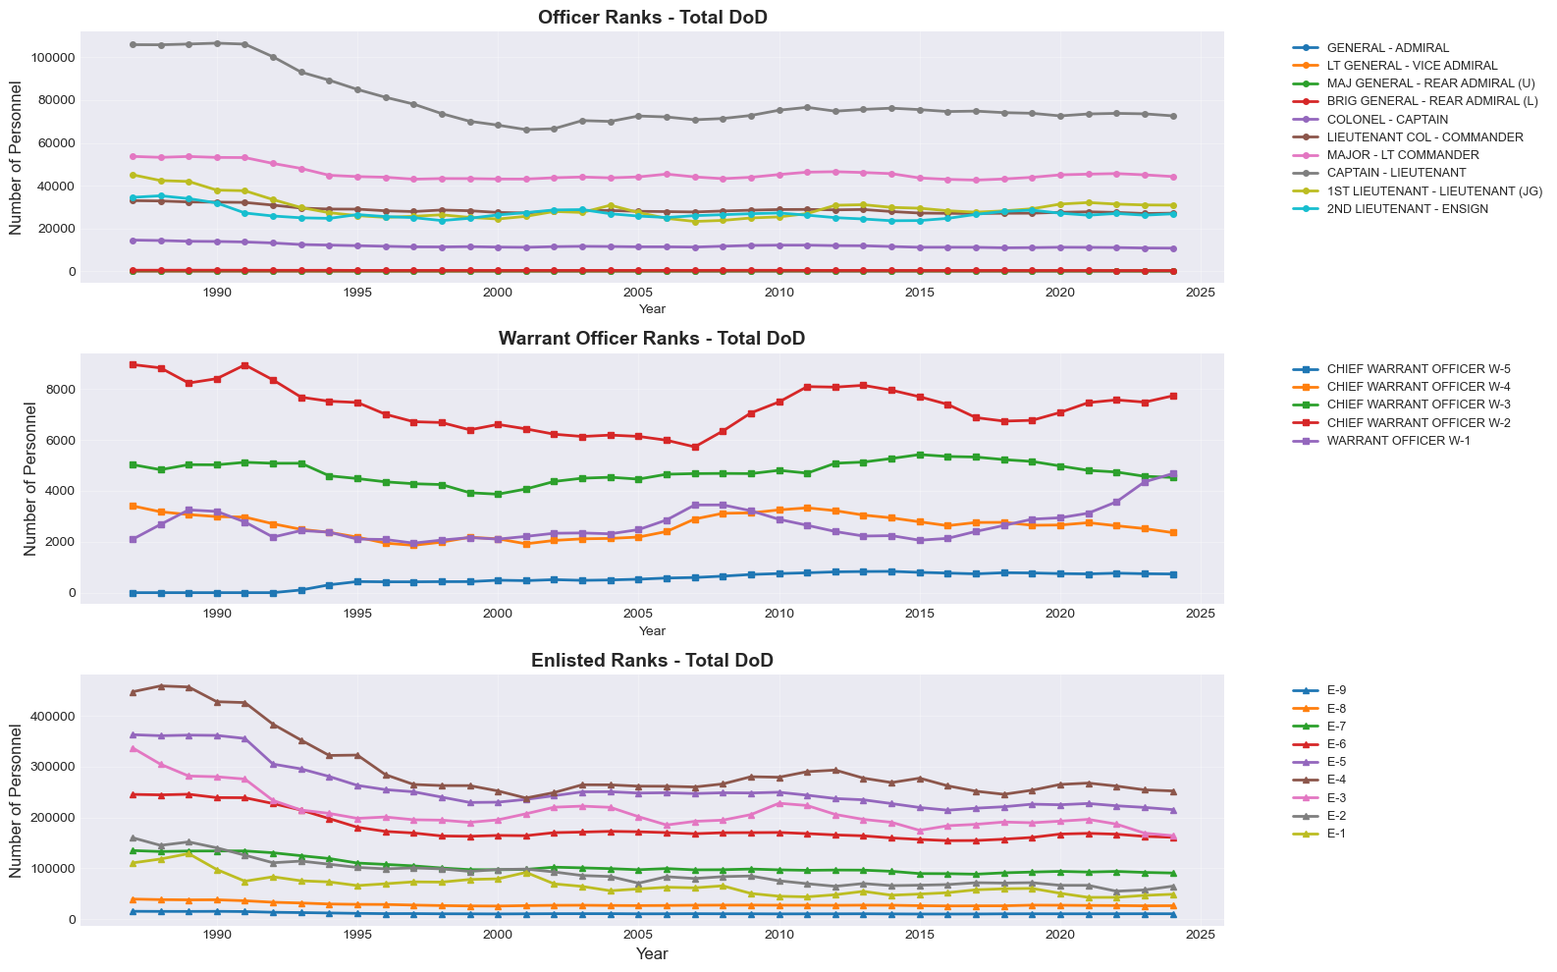

Figure 2 shows the relative sizes of ranks across the whole DoD since 1987, followed by Table 1 with linear regression analysis.

**Figure 2**  
*Relative Sizes of Ranks Across DoD Since 1987*

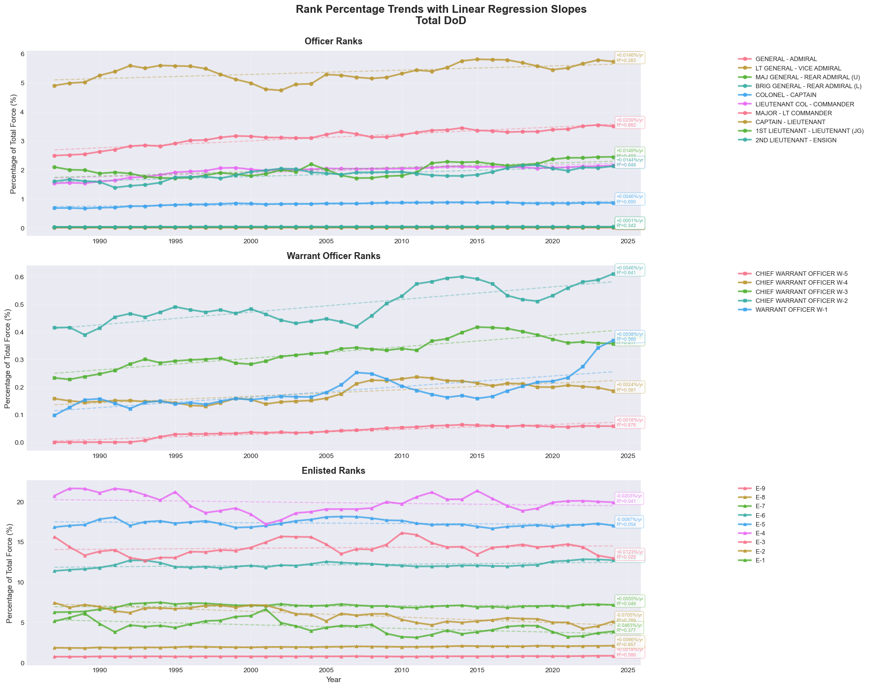

Table 1 shows the linear regression analytics for the relative rank sizes since the Goldwater-Nichols act implemented in 1987. This table shows relative growth for all ranks and rank cohorts except the junior ranks. Junior ranks show a definitive downward slope with the exception of the E-3 rank. The coefficient of determination (R2) reflects the high variability of the rank and the graph shows 2 major increases in the rank that correlate to the 2 surges in Iraq and Afghanistan respectively. The higher recruiting volume for these surges and the longer time spent at this rank for initial entry Soldiers creates a false picture of positive growth. The data and the graph show that E-3s have a smaller relative size today than in 1987.

**Table 1**  
*Linear Regression Analytics for Relative Rank Sizes (1987-2024)*

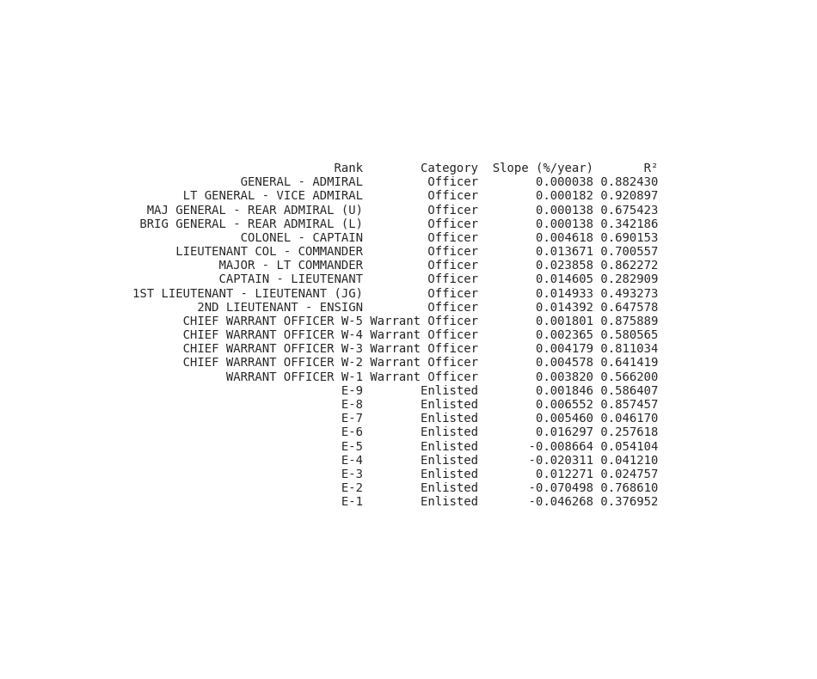

Figure 3 shows DoD civilians by year. The linear regression shows an average loss of 6243.3 billets per year with an R2 pf .33. While the correlation isn’t incredibly strong, the graph demonstrates the overall downward trend of civilian positions matching the drawdown of forces following the end of the Cold War in 1992.

**Figure 3**  
*DoD Civilian Personnel by Year (1987-2024)*

## Bureaucratic Speed

According to the DoD Office of the Director of Administration & Management data, Figure 4 shows the trendlines for median FOIA responses in days (Privacy and Civil Liberties Team, n.d.). FOIA responses are exogenously emplaced bureaucratic overhead. The timelines listed are used as a proxy for headquarters processing and decision speeds on requirements. As the only publicly available metric that measures headquarters timelines for decision processing, this is a reasonable measure of bureaucratic bloat. While counterintuitive, a downward trending line strongly indicates there is more bureaucracy to process these requests faster. This is DoD getting better at bureaucracy.

**Figure 4**  
*Median FOIA Response Times in Days (1987-2024)*

## Organizational Complexity

According to Congressional Research Service (CRS) and the United States Government Policy and Supporting Positions (PLUM book), Presidentially Appointed, Senate-confirmed (PAS) positions within DoD have been expanding significantly since 1987 (Congressional Research Service, n.d.; U.S. Department of Defense, 2017; U.S. Government Publishing Office, n.d.; Marcum et al., 2001). These are high-level executives including the Secretary of Defense, the Deputy Secretary of Defense, the Service Secretaries, and the Undersecretaries. The number of PAS billets must be approved in legislation and has expanded from 36 in 1987 to 66 in 2025 (U.S. Government Publishing Office, n.d.; . This indicates additional high-level responsibilities and growing hierarchical complexity within DoD. Billets and trend line are visible in Figure 5.

**Figure 5**  
*Presidentially Appointed, Senate-Confirmed (PAS) Positions in DoD (1987-2025)*

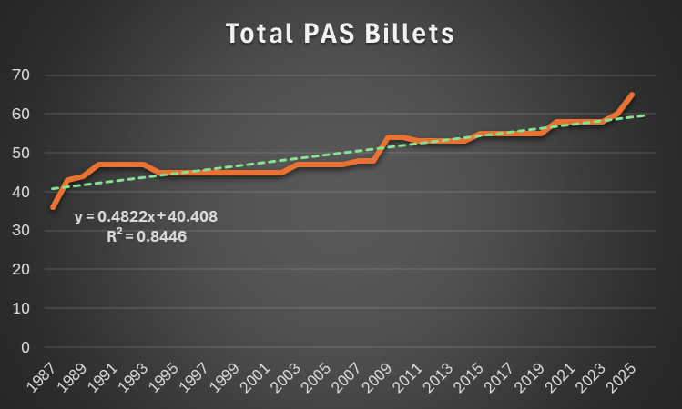

## Policy Complexity

According to Washing Headquarters Services, DoD policy is subdivided into Manuals, Instructions, and Directives. Combing these issuances and removing duplicates, annexes, or appendices issued later from the same original issuance created Figure 6 (U.S. Department of Defense, n.d.). The number of policies per year is the most rapid growth of bureaucratic measure observed. The advent of ubiquitous automations and digital distribution likely enabled more personnel to write and consult on policy as well as dropped the cost to almost free for hosting on websites and emailing to stakeholders instead of running large-scale printing operations. While large-scale deployments may have contributed to the policy bloat, there were long-term and large-scale deployments previously during the Gulf War (1991-1992) and NATO peacekeeping efforts in Bosnia and Kosovo (1994-1995) without surging policies to match. The linear regression trend line for Figure 6 is a poor fit due to exponential growth patterns in the policy numbers. Figure 6 also reflects interesting dynamics as the policy trend changed significantly in 2017 when the National Defense Authorization Act harkened to the 30 year anniversary of the Goldwater-Nichols Act and began reducing GOFO positions and combing headquarters (Schwartz, 2017). 2020 COVID-19 policies should be disregarded as anomalous, but overall this shows an interesting collinearity dynamic between GOFOs and DoD policy numbers.

**Figure 6**  
*DoD Policy Volume by Year (1987-2024)*

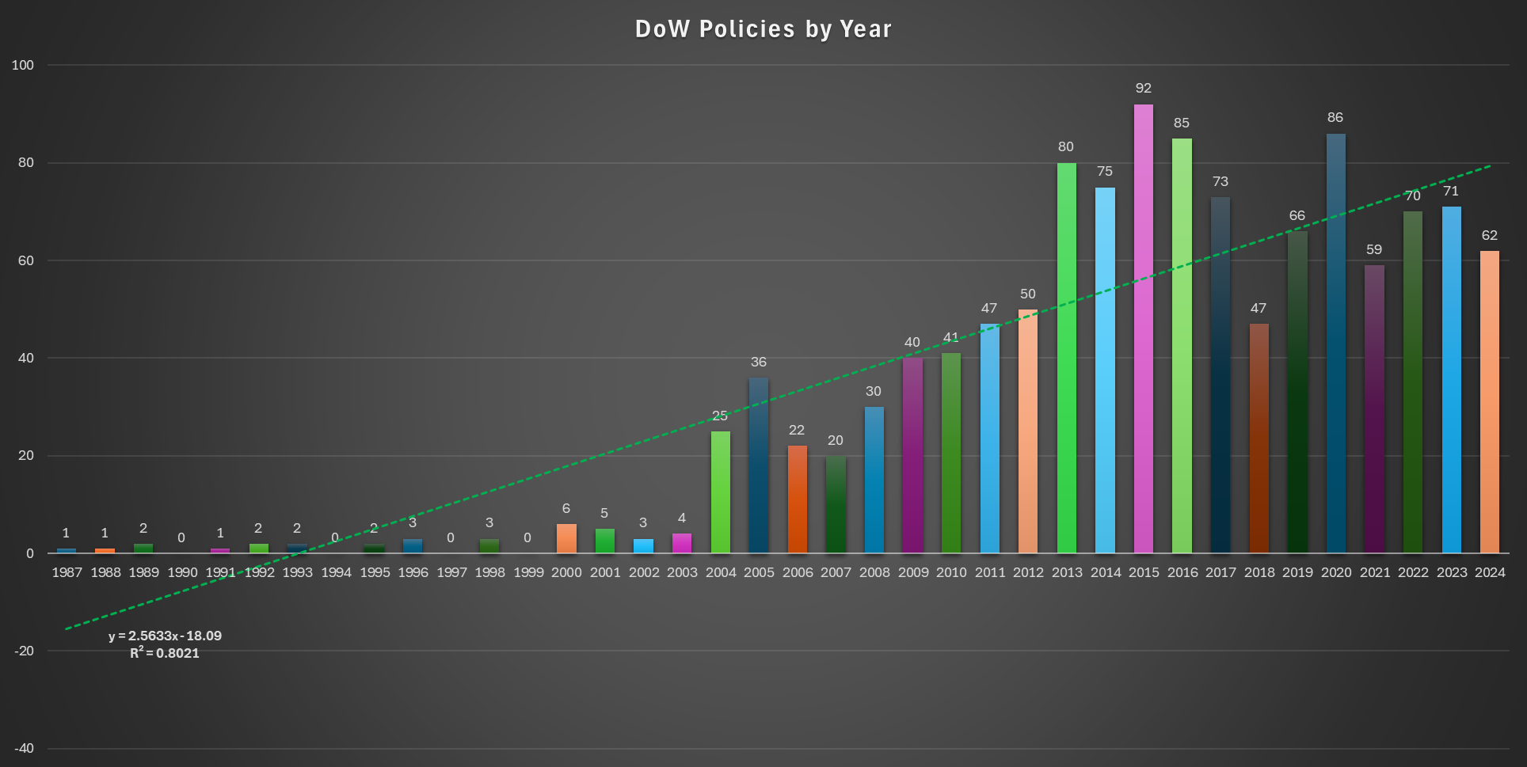

## Political Control

Using House of Representative, Senate, and Ohio Secretary of State data, a list of political party control over the House of Representatives, the Senate, and the Presidency were compiled. These endogenous variables are used to determine collinearity with other measures of bureaucratic growth in order to find potential causal relationships. There was no significant correlations or causations between the in the figure below data and endogenous DoD variables (U.S. House of Representatives, n.d.; U.S. Senate, n.d.; Political Database of the Americas, n.d.; Ohio Secretary of State, n.d.; Election Lab, n.d.). The data is compiled in the in Table 2 below.

**Table 2**  
*Political Party Control of House, Senate, and Presidency (1987-2024)*

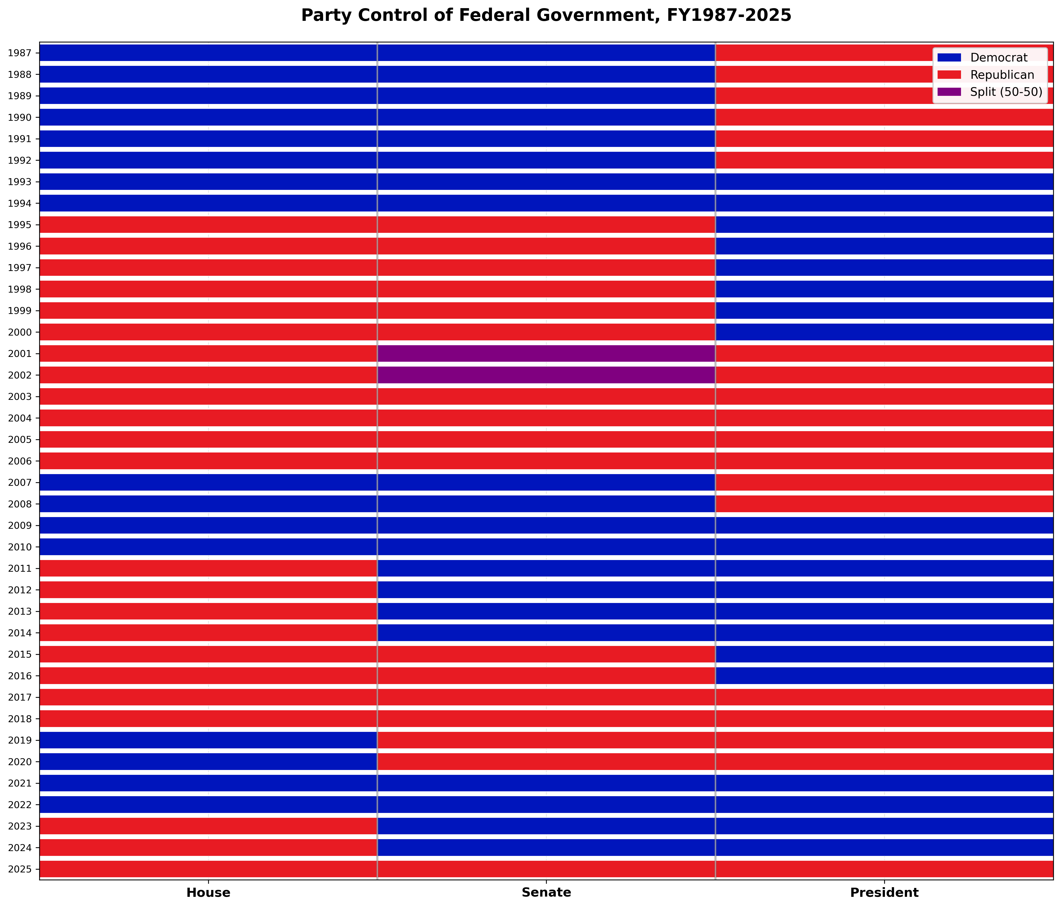

## Gross Domestic Product Growth

Figure 7 shows data from Macrotrends and the Federal Reserve Bank of Philadelphia with annual GDP growth rates for the United States (Macrotrends, n.d.; Federal Reserve Bank of Philadelphia, 2025). The trend line illustrates the familiar to economists “secular stagnation” of the western economies (Eichengreen, 2015; National Bureau of Economic Research, 2015). This data is used as an exogenous variable that was considered but ultimately had no significant correlation with the endogenous variables of the DoD.

**Figure 7**  
*GDP Growth by Year (1987-2025)*

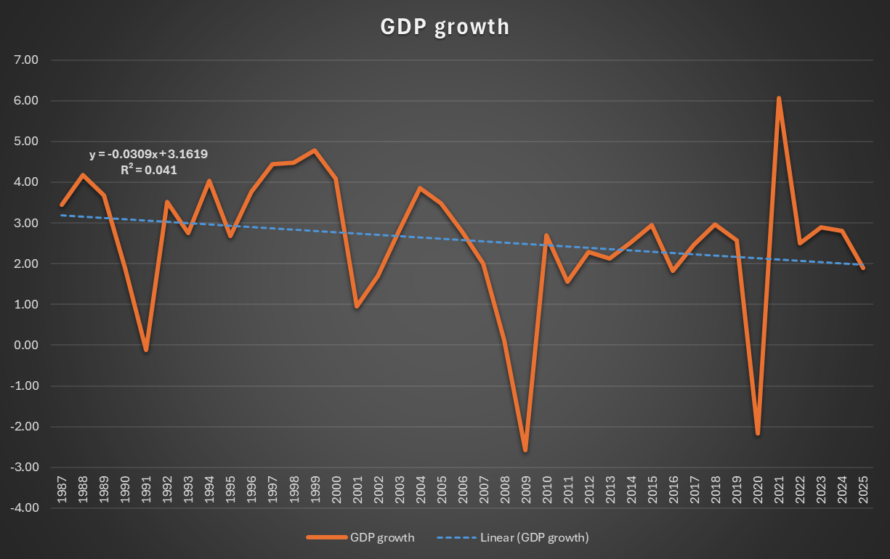

## Significant Conflict

Significant conflict was another exogenous factor considered for influence on DoD bureaucratic measures. Data from CRS and the Army demonstrate a near constant state of significant conflict involvement for the DoD (Torreon, 2024; Phillips 2007). With a constant variable this was not correlated directly with the movements of any other DoD variable.

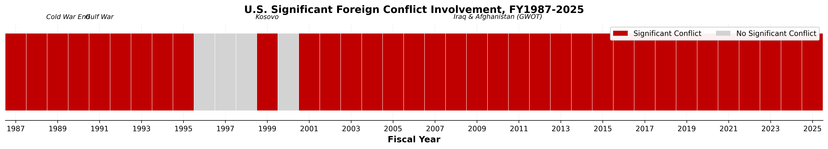

## Combined Variable Analysis and Modeling

The first analytics run against the data were to normalize everything. Where there were relatively normal distributions, z-scores were used. The only exception is DoD annual policy numbers which was exponential so using a log of the numbers was the best way to normalize that growth data before doing z-score normalization. From this normalization we conducted a Least Absolute Shrinkage and Selection Operator (LASSO) Regularized Sparse VAR or Graphical VAR to visualize interrelatedness and initial network dynamics of variables. The LASSO analysis was not as causal as the later complete VAR or VECM but enabled robustness in later variable selection and weighted determinations. Some of these edges are likely spurious due to limited observations like the middle enlisted cohort relative size dampening the President being a Democrat. Additionally, the Sparse VAR only captures short run dynamics at lag 2 (2 year influence) not overall trend analysis like long-term bureaucratic growth or the steady decline in relative size of the junior enlisted cohort while the field grade officer cohort expands. Figure 8 is an initial visualization of immediate influences. The most influential variables for the sparse VAR (most outbound edges) were:

1. Total PAS Positions (14 connections)
2. Democratic Control over the House of Representatives (14 connections)
3. Republican Control over the House of Representatives (14 connections)
4. General Officers and Flag Officer cohort relative size (11 connections)
5. Total Civilian positions (9 connections)

Edgetables and adjacency matrices can be found in Appendix A.

**Figure 8**  
*Sparse VAR Network Graph on Normalized Variables*

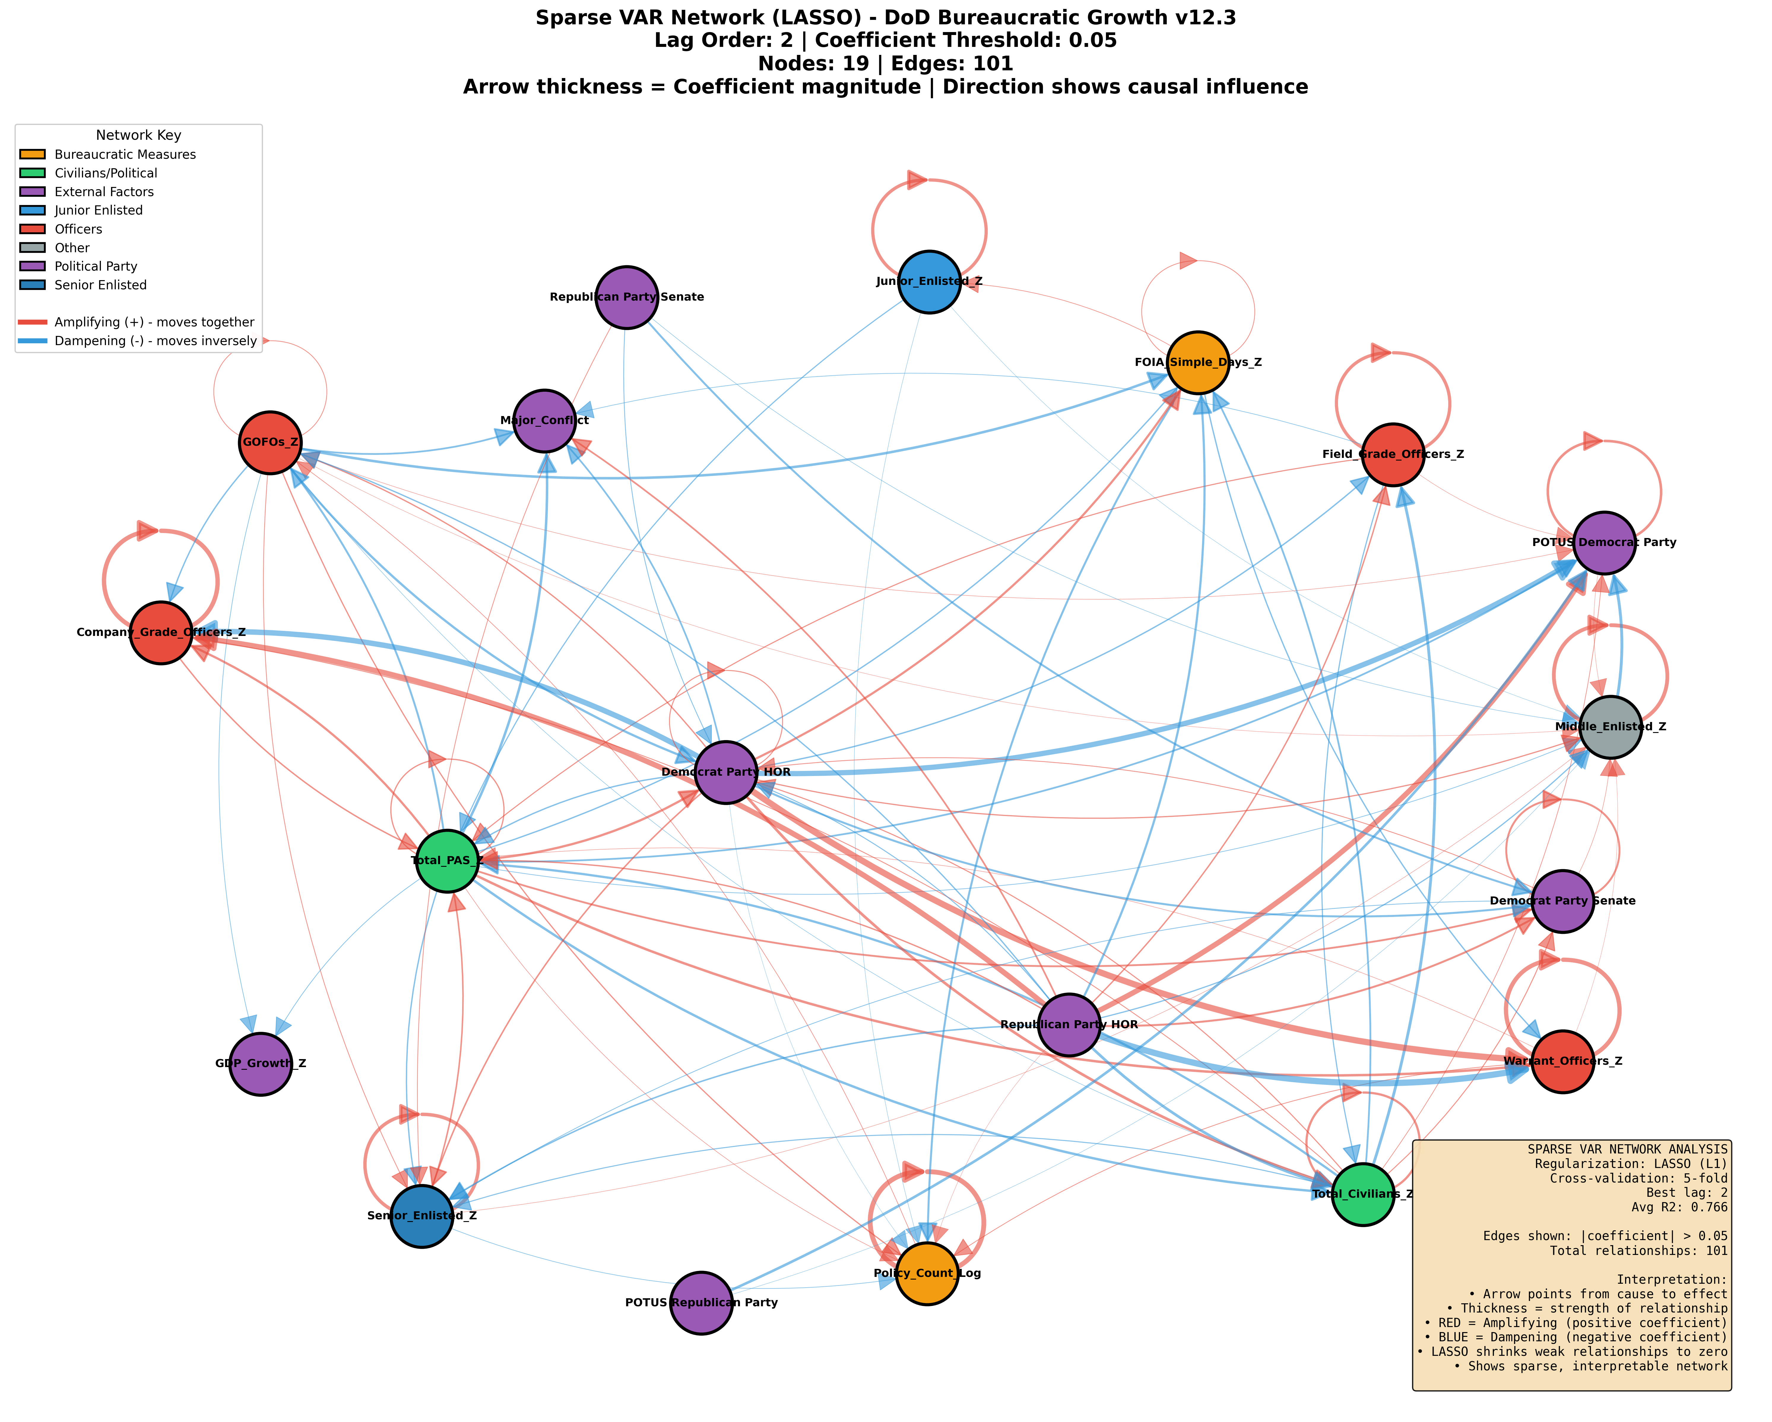

The next step was using Granger pairwise causality test to determine the top variables. This was run and then integrated into a network diagram where a composite centrality score was used to highlight the most influential variables. This was only run at lag 4 so long-term trend analysis is still absent, but for robustness, short-term influences, and variable selection for VECM this was a required test. in the Table 3 below are the centrality measures and Figure 9 contains the network diagram and influential variables by centrality. Centrality measures except degree were normalized by dividing the measure by the highest value among the variables and multiplying by 100, giving each measure a percentage rank of the highest possible value. For the composited scores, degree and each normalized centrality score was added together and divided by 4 to produce the final composite. While warrant officers had significant centrality, most of it was in-degree centrality, implying they were most influenced, not the most influential. This matches the officers experience where technical experts must both abide by the bureaucratic rules and ensure compliance by other cohorts to ensure mission continuation.

**Table 3**  
*Granger Pairwise Causality Network Analysis*



**Figure 9**  
*Granger Pairwise Causality Network Analysis*

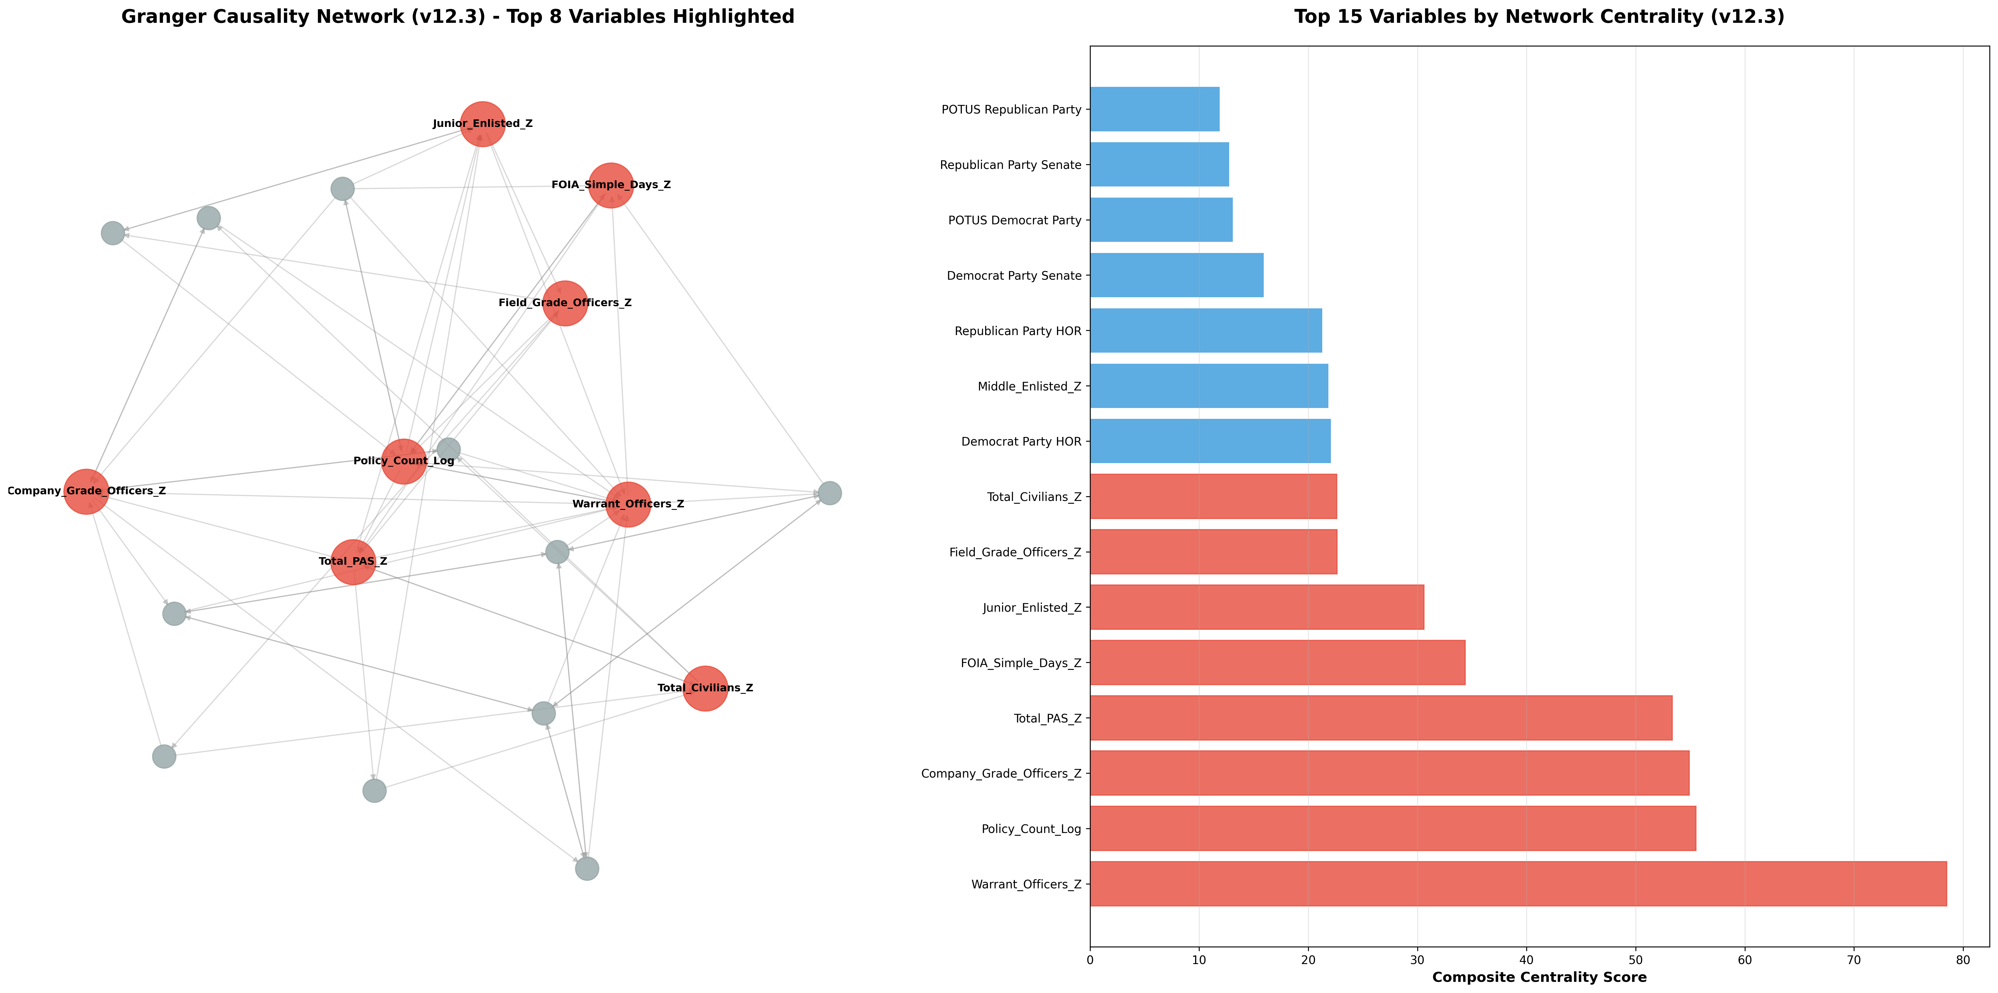

Figure 10 shows the comprehensive Vector Autoregression was run to analyze short run interactions between the most central variables. The VAR assessment showed spurious or unrelated interactions at lag 1 as expected in an organization of the size of DoD cannot react on annual scales with structural or functional changes. These correlations included the warrant officer cohort strongly influencing the legislation to make additional PAS billets, or company grade officer cohort strongly influencing DoD-wide policy; neither of which is feasible or sensical. However, when looking at lag 2 (second year influence of changes) we notice that warrant officers and company grade officers attempting to dampen policy while field grade officers and civilian employees try to amplify it. There are also short term influences between warrant officers dampening civilian employee numbers which makes sense as the technical specialists they can be interchangeable with many of the civilians normally hired as technical specialists. PAS billets also seem to dampen junior enlisted numbers which was noticeable on the long-term trend analysis and reflected even within a 2 year lag. Figure 10 shows the influence heatmaps and Figure 11 illustrates the respective network diagrams of the variables influences on each other.

**Figure 10**  
*Comprehensive Vector Autoregression (VAR) Heat Map*

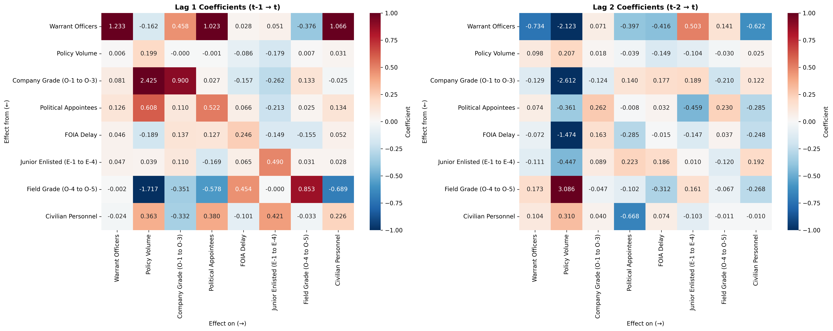

**Figure 11**  
*Vector Autoregression (VAR) Network Graphs by Lag*

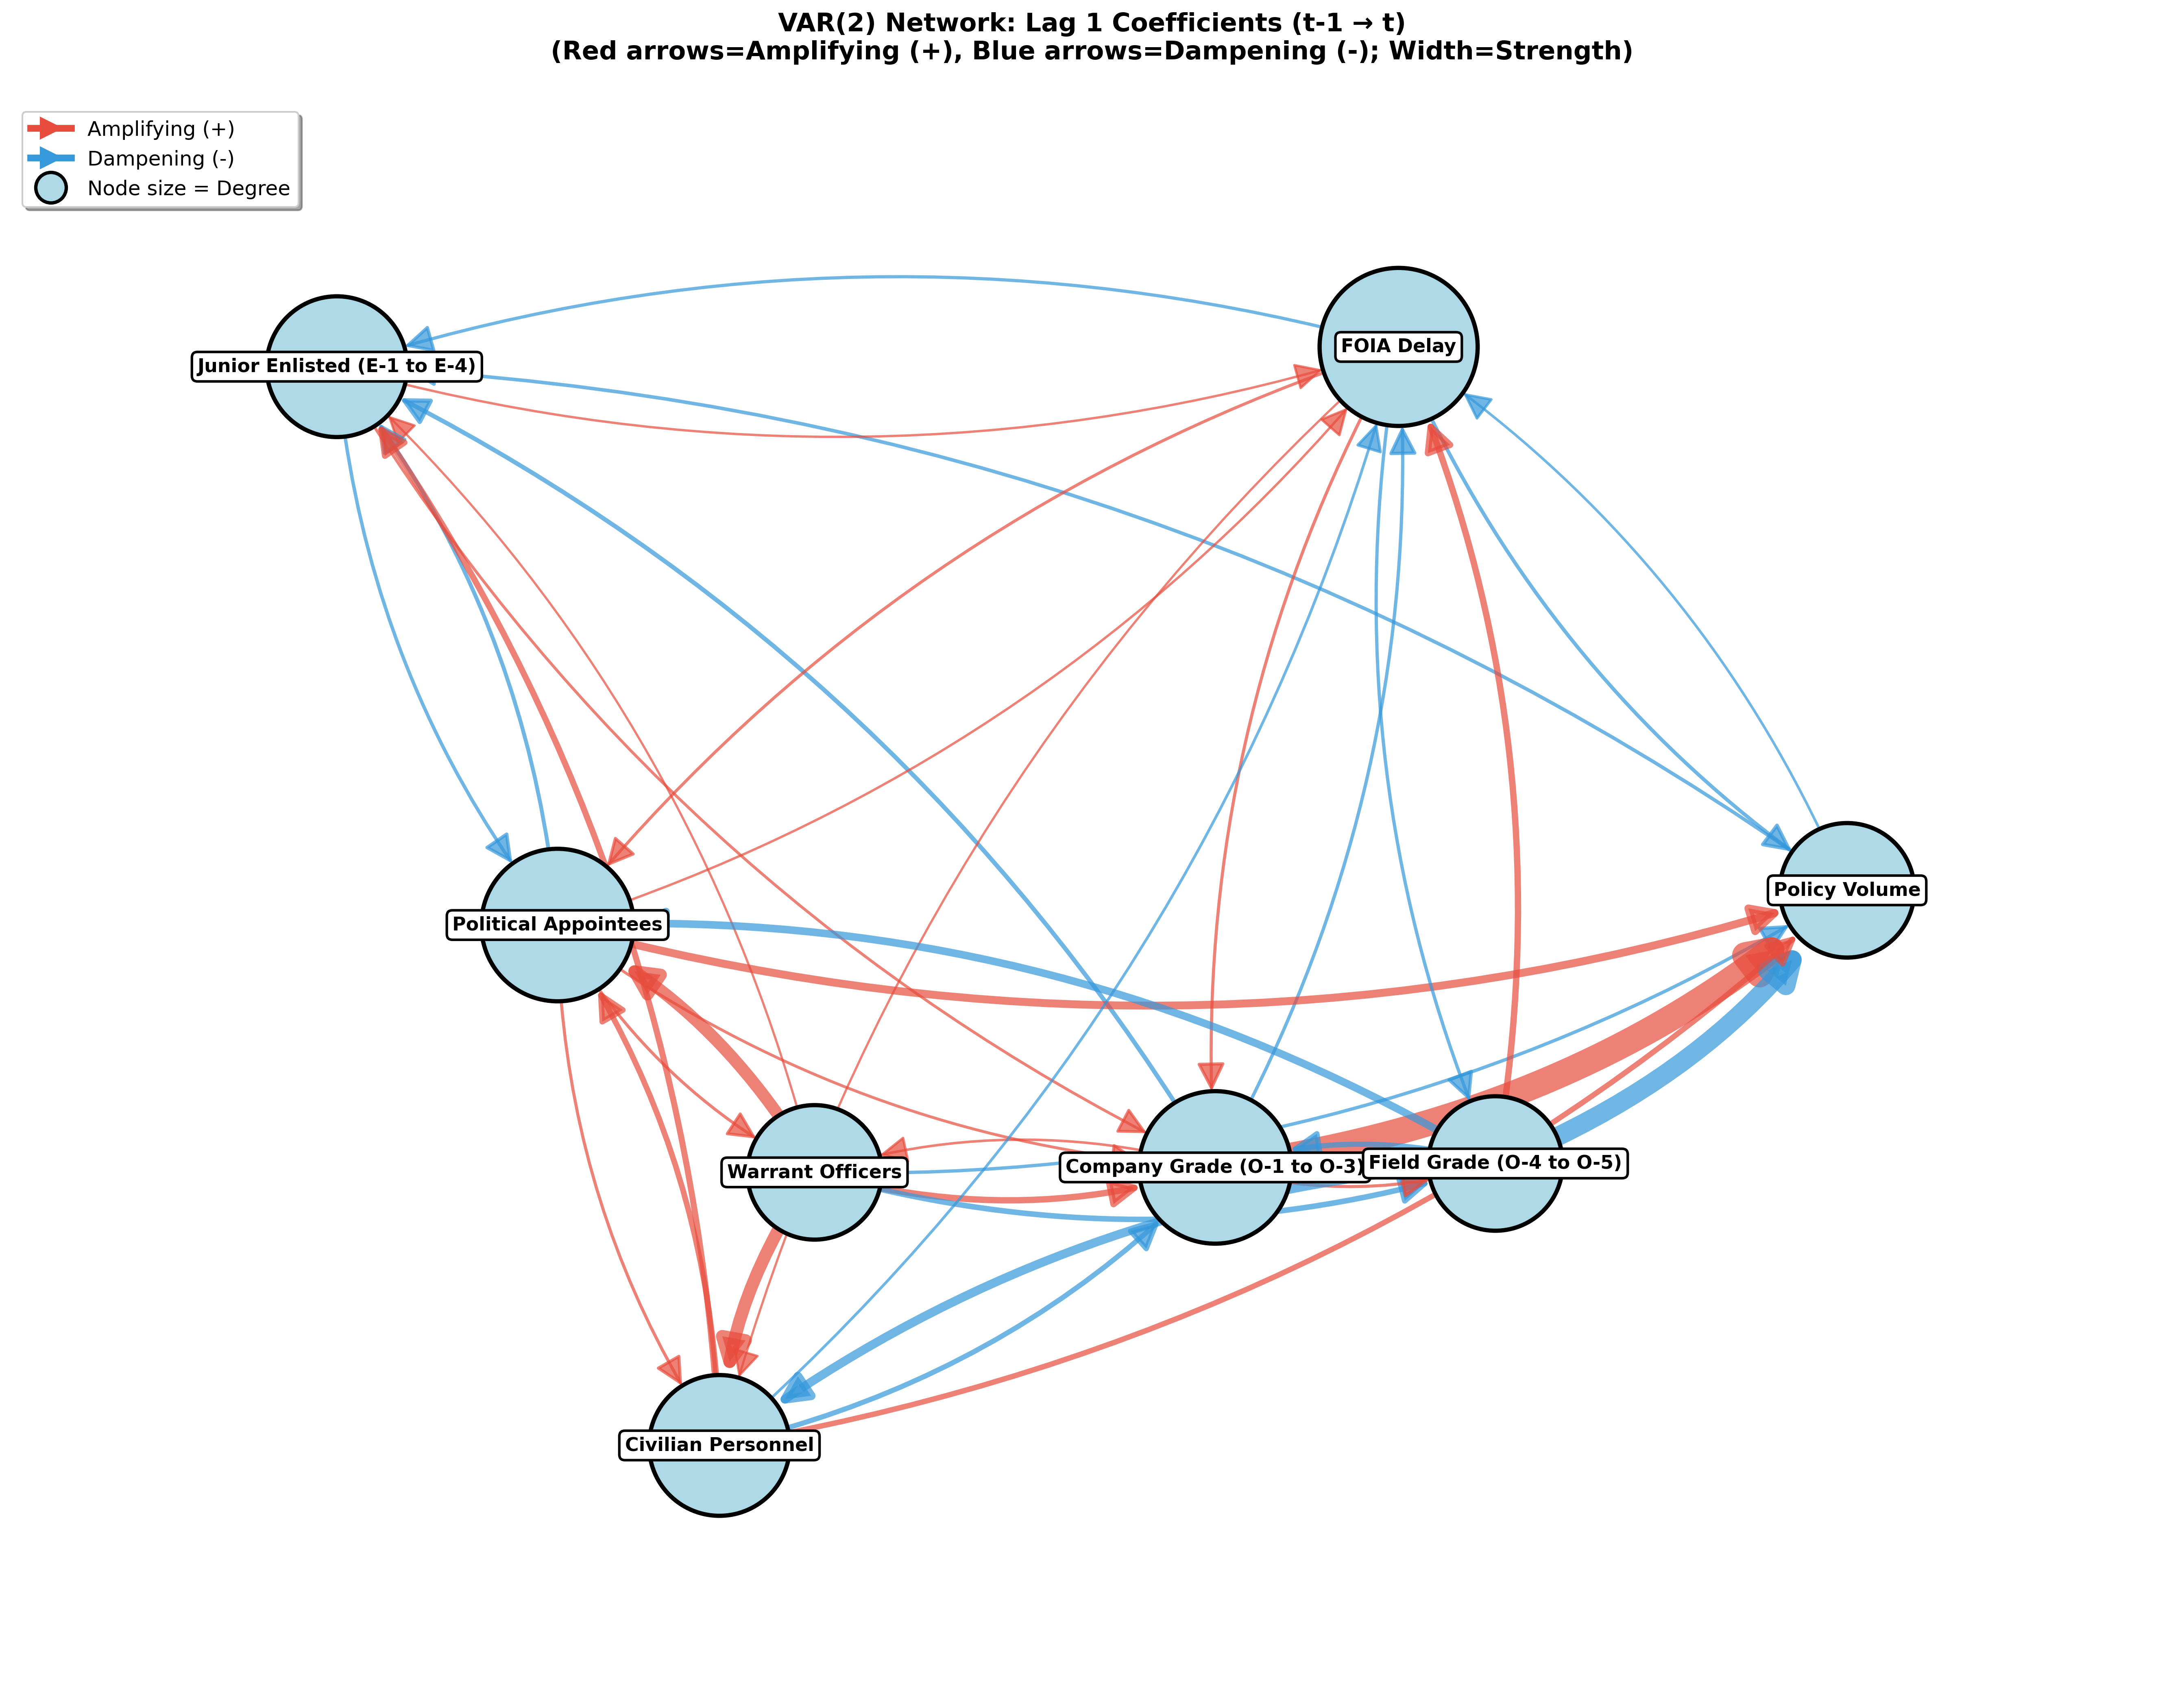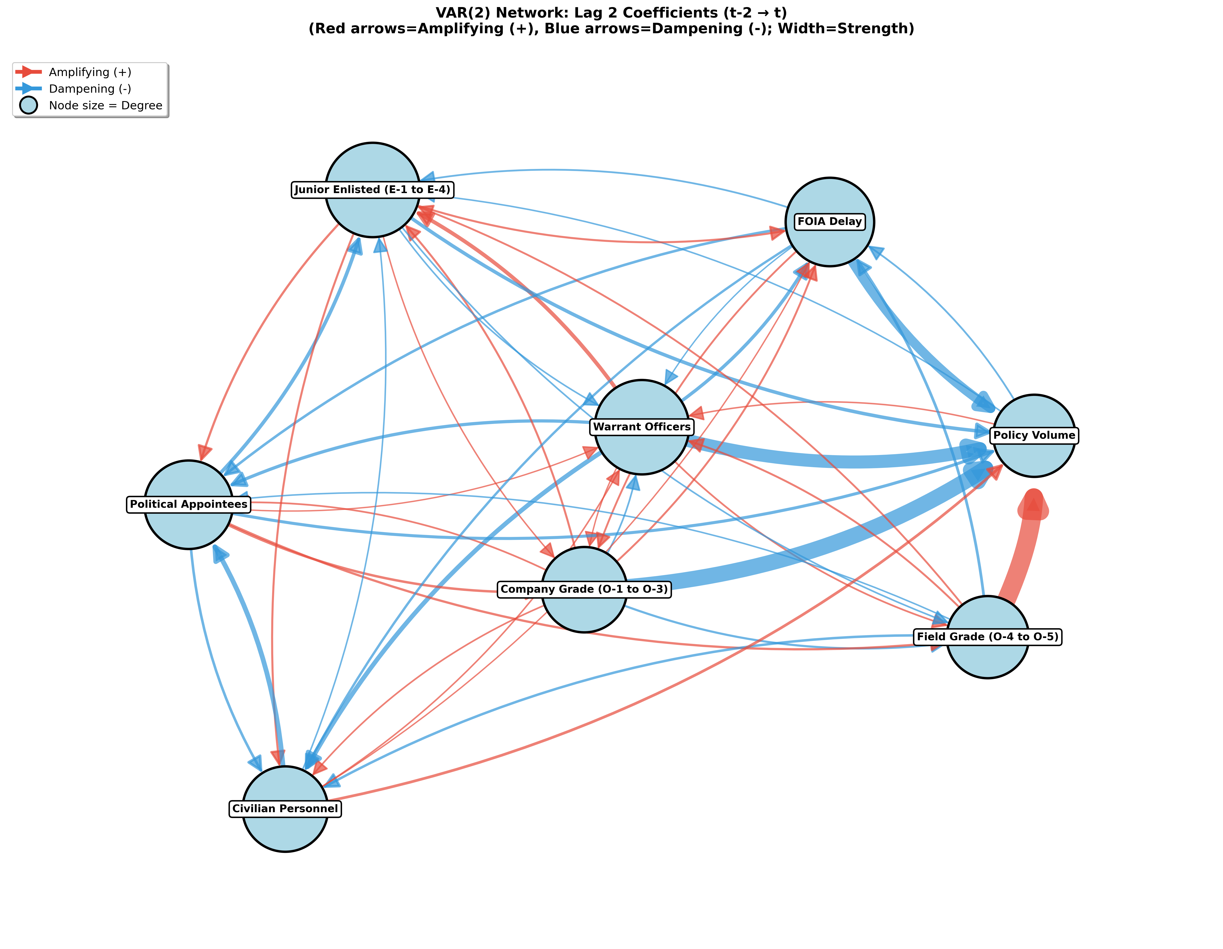

The VAR lag 2 showed significant stationarity on all variables except the civilian cohort and the Field Grade officer cohort. This indicated that there are long term trends that VAR is unsuitable to display and a Vector Error Correction Model should be used to analyze these long-term trends. A Johansen cointegration test was run to determine cointegrated variables over long-term in order to direct the VECM model correctly. There were several cointegrated variable groups of high trace stat. Using some of the previous analysis, political variables were ruled out a spurious cointegrations; but field grade officers were placed into the variable list though the stationarity was borderline. Johansen tests are robust to 1 borderline variable, and long-term trends show stationarity of the field grade officer cohort but mathematically was closer to I(0) without differencing. The authors’ experience with this rank in DoD, the inclusion of other force structure components, visible long-term trends, and using out-of-sample testing on the final model with 46% accuracy indicated this borderline variable was an acceptable inclusion. in the figure below are the final variables used for the VECM rank 2 model.

**Table 4**  
*VAR Lag 2 Stationarity Test Results (ADF Tests)*



The only significant difference in variable selection here was that civilian employee numbers were already stationary and would not be acceptable for a VECM model. While the VAR analysis had civilian employees, they are replaced with the General Officer/Flag Officer (GOFO) cohort in the VECM model due to the long-term trend and cointegration. The results of the VECM showed that GOFOs, FOIA response timelines (as a substitute for command processing time), and political appointees are the most significant drivers of long-term bureaucratic growth dynamics in the long term. For immediate and short term changes, policy volume had the greatest impact followed by company and warrant officer cohorts.

**Figure 12**  
*VECM Short-Run and Long-Run Variable Influences*

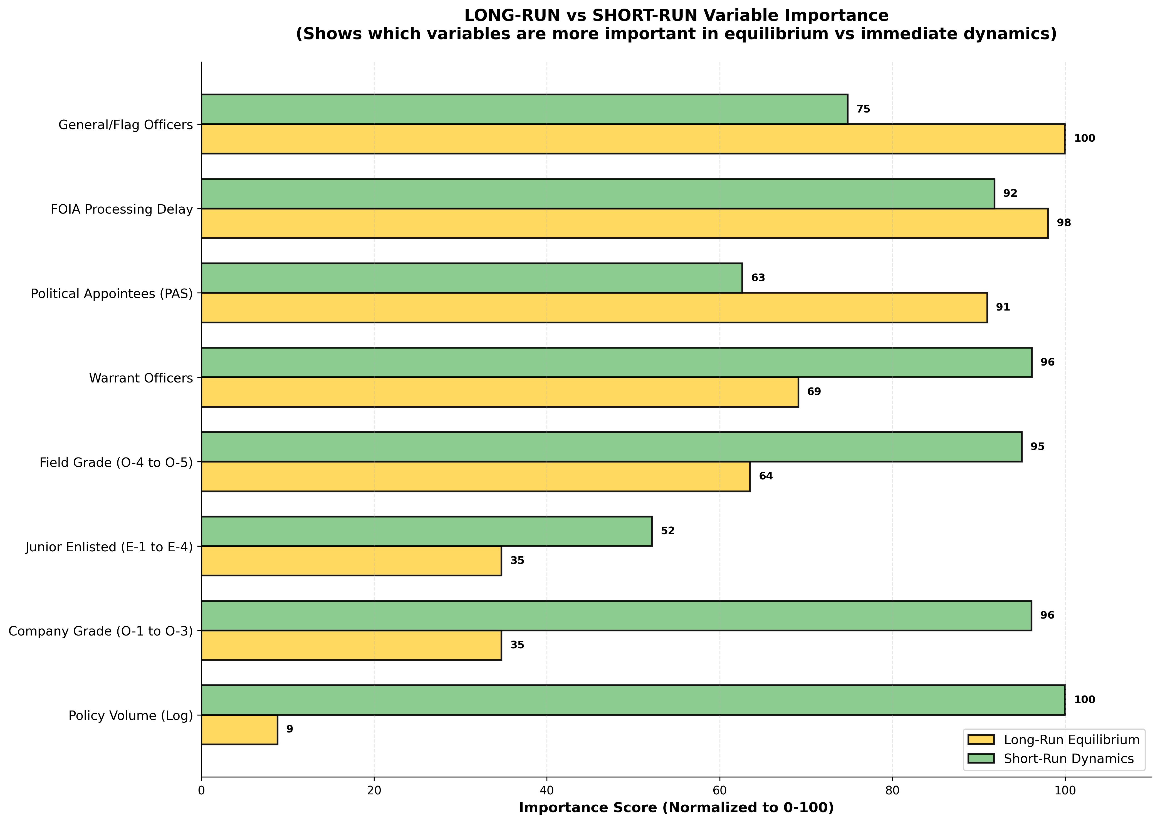

Figure 13 shows the variable network diagrams from both short run (left) and long run (right).

**Figure 13**  
*VECM Network Diagrams: Short-Run and Long-Run Dynamics*

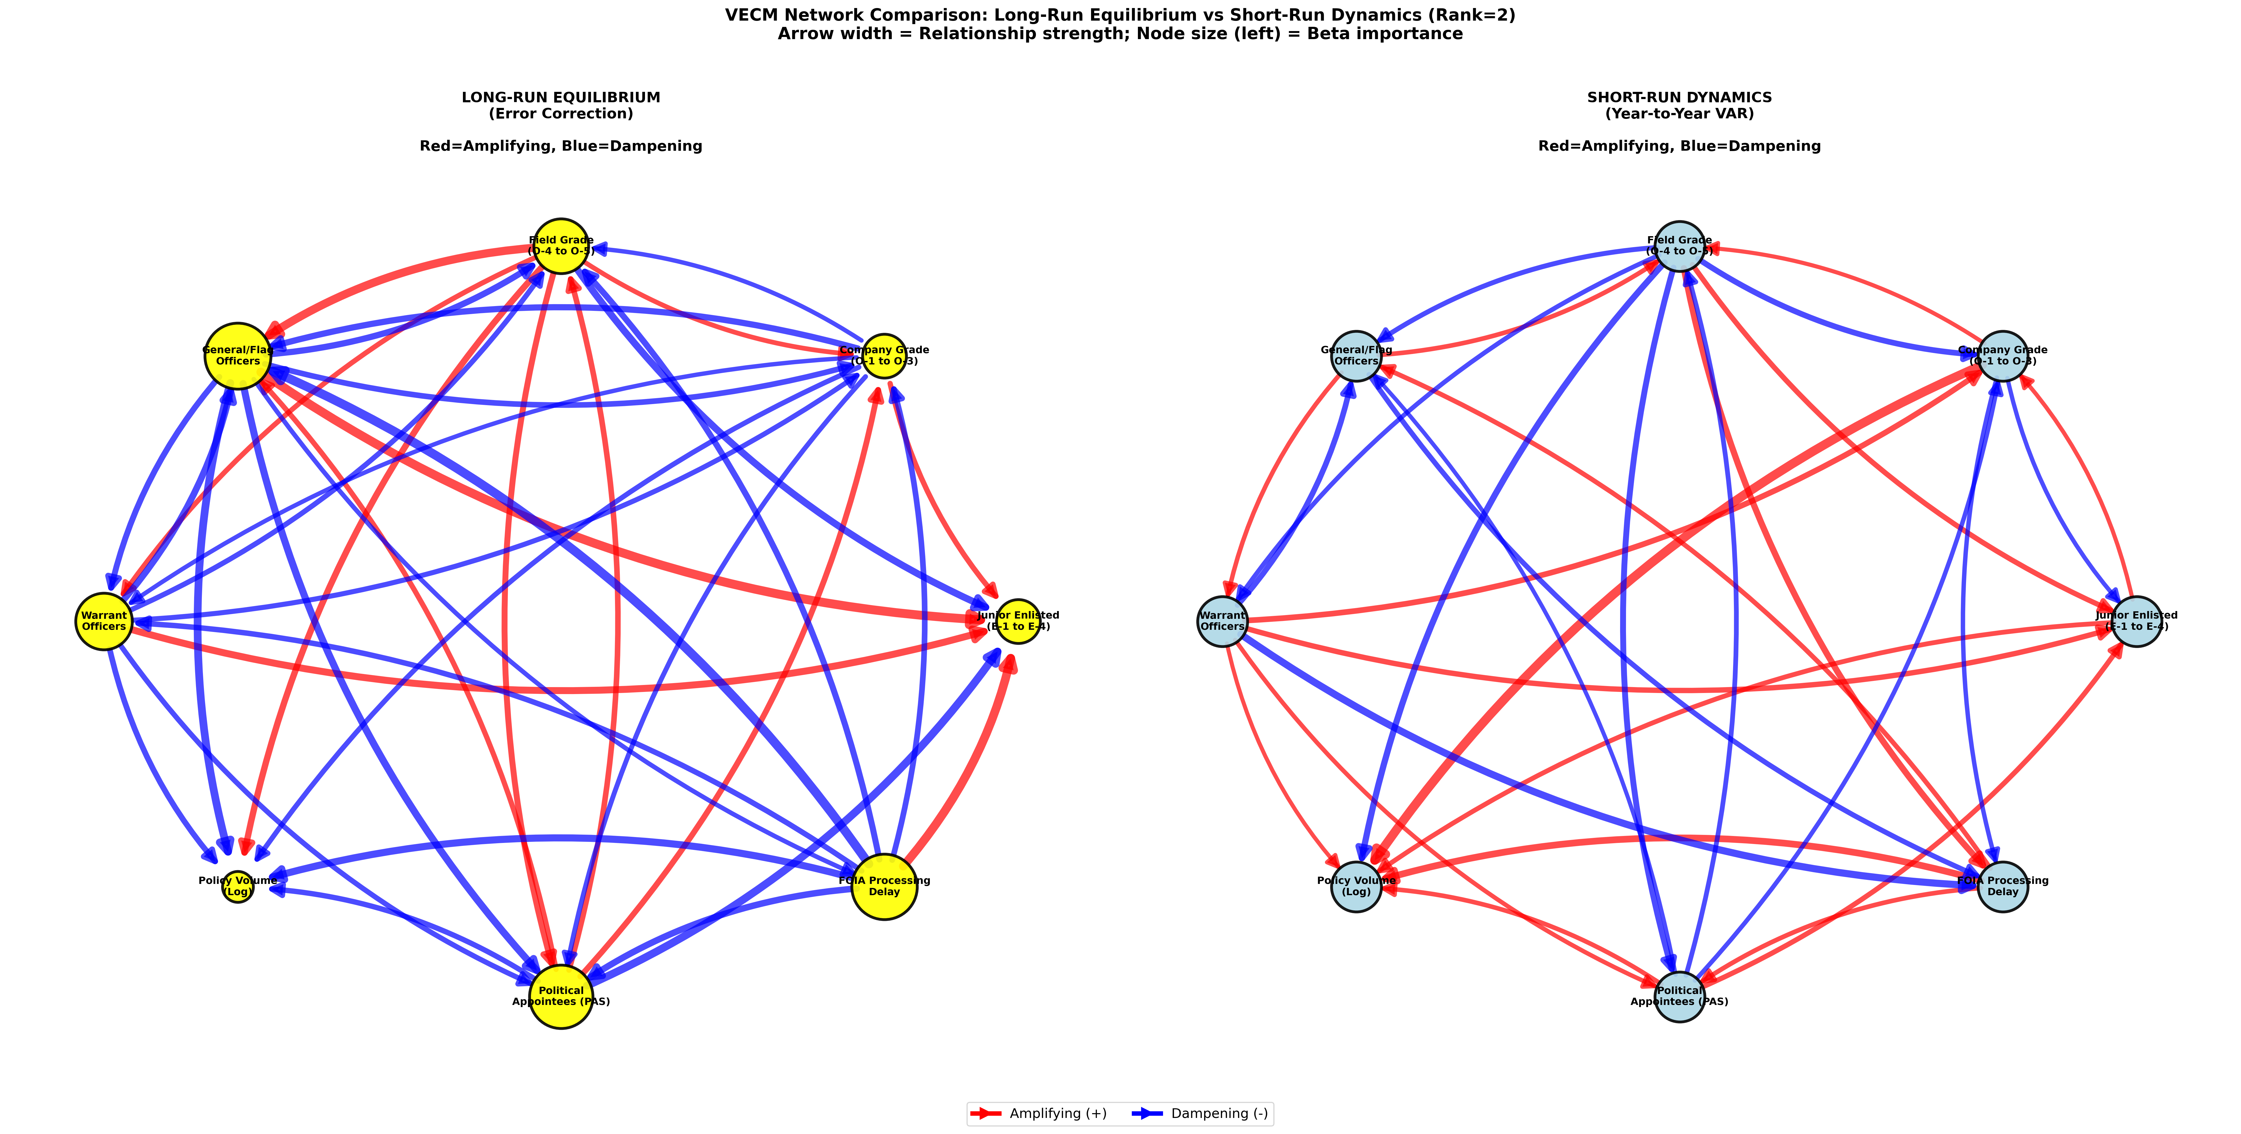

Figure 14 shows the heat map of magnitudes of influence on both sort and long-run model dynamics. Political Appointees and staff processing times are still the dominant drivers of the rest of the variables in the long term. While staff processing times are esoteric and difficult to determine causality for, the reductionist approach to political appointees and GOFOs as a definitive number with simple legislative causes is an easier to digest measure.

**Figure 14**  
*Heat Map of Influence Magnitudes (Short-Run and Long-Run)*

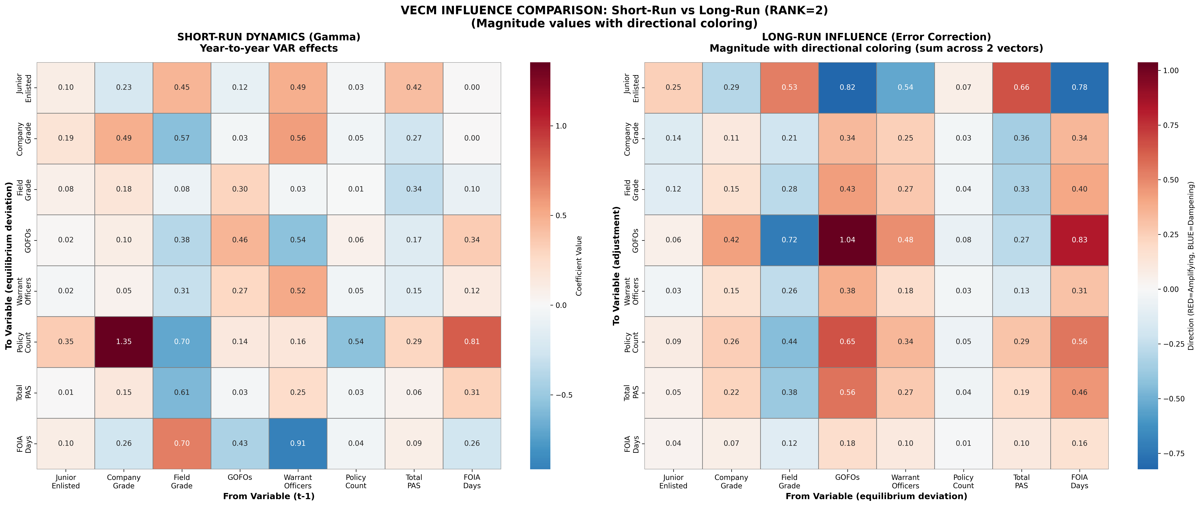

Final coefficients were written into a NetLogo model. This model was run stepwise with variability introduced in the VAR, error-correcting, and the amount of noise in the system. The model was run stepwise in behavior space for 300 iterations for each variable resulting in 8700 total runs. This data was interpreted to find which variable crossed the 2 standard deviation line first. The intent was to find the first mover within the system as a causal factor. The data and the graphics in the figure below show that policy numbers are the first movers about 1/3 of the time with company grade officers and GOFOs taking around 12% each with all other variables between 7-9% of the time being first movers. The dynamics for policy numbers may be due to different normalization (used log transformation instead of z-scores, and didn’t further normalize) which could have skewed the coefficients. However, when the log transformations were z-score normalized, the model significantly broke down and lost relevance for most variables.

Additionally, this finding may not indicate causal relationships just because it was the first mover over 2 standard deviations in the grouped variables. Figure 15 below is a violin chart illustrating the volume of runs that crossed 2std by variable and step. The mean and median crossing hashes are also marked on the lines. It should also be noted that this model is highly stable from the error-correcting and 2 standard deviation departures didn’t occur until hundreds of years into the modeled future, it was just the causal dynamics were not easily observable until that point. With company grade officers moving followed by GOFOs, this model looks to be blending the short run and long run dynamics with significantly more weight placed on the short run coefficients. Future iterations of the Netlogo model will reflect this knowledge and likely overweight the long run error correction despite the dampening effect on visible dynamics in the network.

**Figure 15**  
*Violin Chart of Modeled First Variable Movers Past 2 SD*

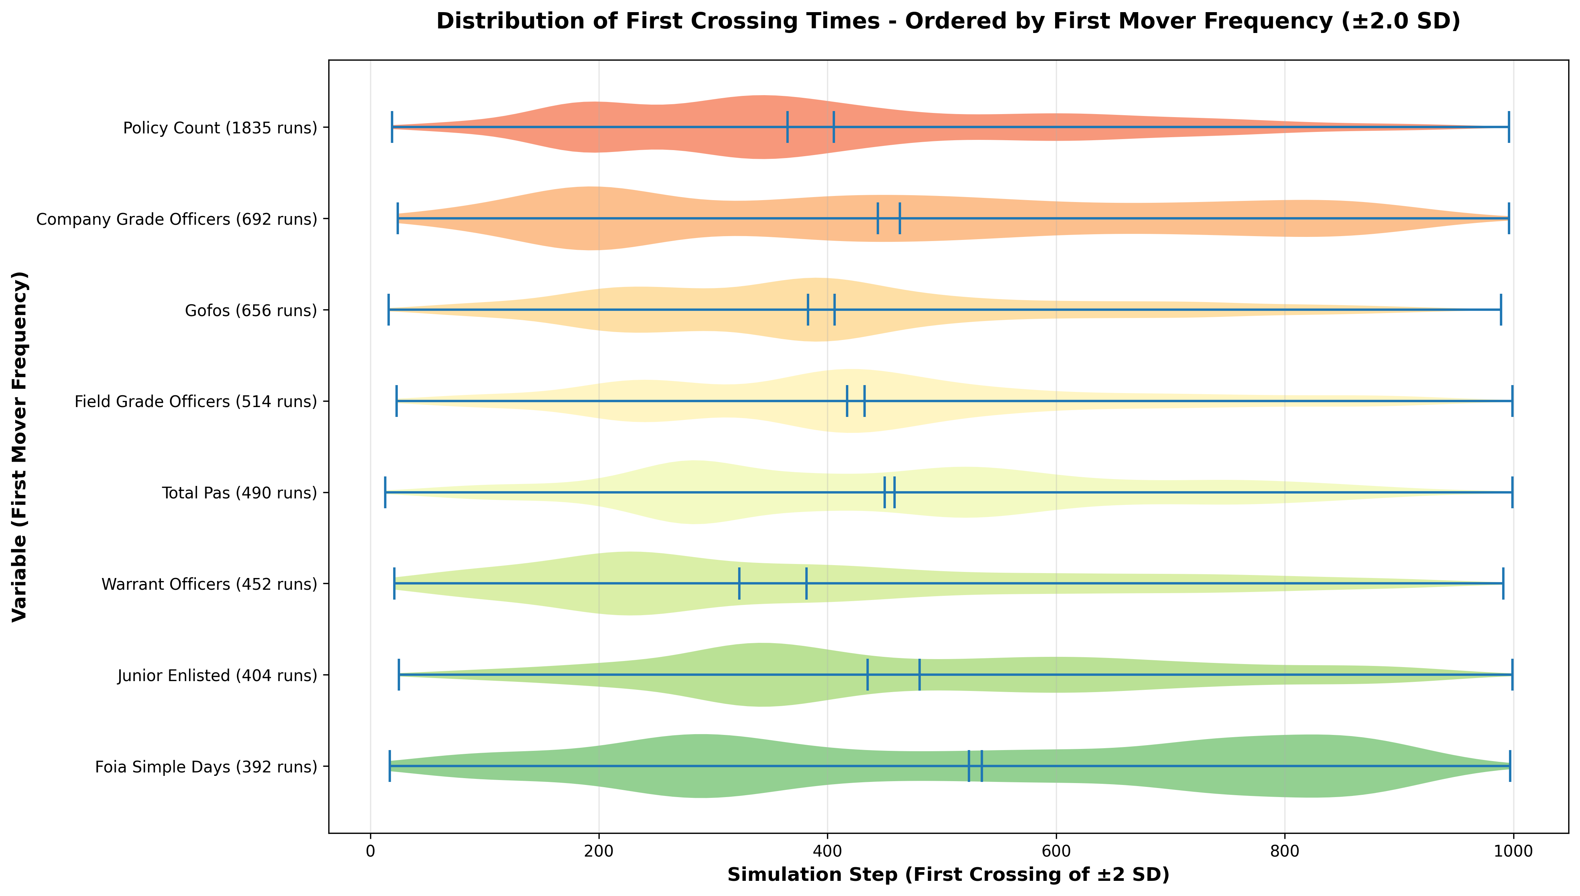

# Chapter 6: Discussion

Weber and Michels both knew that bureaucracy was both the best way to manage large-scale organizations and inevitable to maximize efficiency in an increasingly technological organization. Their Iron Laws and Iron Cages are not yet escapable. Using this framework, the equilibrium of the VECM model must represent the bureaucratic growth based on the variable selected. Therefore, the single most important variable for bureaucratic growth since the Goldwater-Nichols act of 1987 within the DoD has been the growth of General Officers and Flag Officers. FOIA response times were used as a substitute for headquarters processing times, and political appointees were used as a substitute for organizational and hierarchical complexity which are more esoteric measures and drivers of bureaucracy.

Interpretation of Findings

While not intuitive or reductionist like pure numbers of GOFOs or political appointees, FOIA response times seemed to have the most outbound edges and almost no majorly influential inbound edges for long run influence. An interpretation for this is that as headquarters processing speeds slow down, more generals, policy, appointees, and field grade staff officers are added to speed things back up and restore some kind of equilibrium. GOFOs are heavily reinforcing but also indicate organizational complexity as they will lead sub-organizations with either tens of thousands of forces, or equivalent strategic responsibilities. Adding more GOFOs means the organization has evolved a major new combat unit, or a new strategic responsibility, and political appointees will follow for oversight. The expectation was that the field grade officer cohort would be the most bureaucratizing variable based on experience and the majority of staff officer positions belonging to either the field grade or civilian employee cohorts. This is likely not borne out in the data due to staff officers being good at staff work. Adding more field grades officers looks to dampen other bureaucratic variables, likely by being efficient. Once more counterintuitively, more managers and staff officers makes things less bureaucratic as seen by their cohort being the only one to dampen most of the other variables in the long run analysis.. The cause of bureaucracy, at least within DoD, appears to be additional executive-level decision makers and slowing standard processing times, and the slow processing times are caused in part by the additional executives in the long term. Additionally, both GOFOs and FOIA timelines seem to dampen junior enlisted growth significantly.

Short run dynamics do show that initially field grade officers significantly slow down headquarters processing, but speed it up in the long term. It looks like initial build-out of a new organization with new responsibilities and staff officers slows the process for a few years but eventually course corrects. This matches well with the demigarchs finding their places and implementing policies and procedures to standardize the staff work. As a warrant officer the author also notes that the warrant officer cohort produce an immediate dampening effect on staff processing times. The short run amplification of bureaucracy by field grade officers was visible in both the VAR and the VECM models with the VAR showing similar amplification for the civilian employee cohort. This follows the entrenchment by staff officers and civilians into their demigarchian roles. On the long run though, these staff efforts do add efficiency and enable a headquarters to operate effectively. The real driver is the continual adding of executive positions which continues to create new staffs and demigarchs that take years to reach equilibrium and efficiency. The overall inflationary pressure for bureaucracy is driven by adding executive positions within the GOFO and PAS cohorts. Eventually the system will reach a stable state, but for several years after the new position, there is a surge in policies and a slowing of processing speeds. The cumulative effect of all of these positions throughout the DoD is a constant upwards bureaucratic drift.

The VECM did not match all long-run trend analysis; however, there was a strong perturbation or even a regime change in 2017 for the force structure of the DoD (Schwartz, 2017). The new National Defense Authorization Act (NDAA) enacted GOFO reduction, personnel reductions at headquarters, and delayering of various positions to simply the organization hierarchy. It was not a coincidence that this was the 30th anniversary of the Goldwater-Nichols Act. In 2017, the relative size of the GOFO cohort and the junior enlisted cohort began trending together instead of inverted. This complicated appropriate modeling, but relative GOFO numbers are recovering faster than the junior enlisted cohort already. This regime change was noticeable in the data, and the model breakdown is what drove the author to research the causes indicating excellent predictive power of the VECM from 1987 until 2017. Additional analytics that required research was the large drop in GOFOs in 2023. This was caused by Sen Tuberville holding up confirmations for senior DoD officers and cascading through the GOFO ranks. If 2023 data were dropped, the numbers for junior enlisted and GOFO cohorts would show they are diverging again already.

## Theoretical Implications

While demigarchs undoubtedly exist in DoD, they are not the first movers for additional bureaucracy and work diligently to reduce it. These individuals initially add bureaucratic rules and processes to speed up staff processing. The field grade staff officers and the civilian employees who work in these staff are responding to the new executive billets. The safest and longest running new executive positions are declared in law and presidentially appointed. Their permanence as positions outweighs the personalities thereof. With the longstanding path dependence of the staff, practices, and procedures of these positions, the outflow of bureaucracy through the DoD likely begins here. While there are many reinforcing mechanisms and GOFOs drive a lot of it, their numbers are much more dynamic and more easily influenced by higher authorities within the political realms. Policies seem to be endstates of this system of variables. While influenced by many other variables, policy seems to have no long term influence on any other variables. It must be internalized and normalized with no significant disruptions to day-to-day operations. After the Goldwater-Nichols act, bureaucratic measures immediately started trending upwards, and the 2017 NDAA will likely also prove insufficient as it only affected staff personnel who actually reduce some of the bureaucratic load, and a few GOFOs while actual PAS billets were increased in both 2020 and 2024.

The DoD will continue the dynamic oscillations of building and destroying GOFO positions and staffs indefinitely until the proliferation of the PAS positions is addressed. This bureaucratic inflationary pressure continues to drive multiplying policies, slower headquarters processing, more GOFOs, and overall more bureaucracy.

## Limitations

There are several limitations on this study. The most significant limitation is the necessity of limited data availability. DoD must limit public access to much of its data to avoid exposing vulnerabilities or critical capabilities to adversaries. This means much of the desired variables had to be substituted with structural proxies where data was available as seen with FOIA response times as a proxy for headquarters decision timelines, and PAS billets as a proxy for organizational complexity. Additionally, DoD has reason to intentionally obfuscate a subset of employees and organizations involved in sensitive operations from overall public knowledge and accounting. While this number is likely a small representation and probably normally distributed across the various ranks, there is no way to confirm.

Another limitation is the short timeframe and limited data, with only 38 observances, there is significant concern about overfitting the VAR and VECM models. Other limitations were built in with overrepresentation of rank structures and not putting civilian employees into junior/senior/executive cohorts. The variability of the political landscape that controls the DoD inserts significant year-to-year dynamism into the system which causes predictive difficulty. This was indicated previously where the cointegration structure of the data breaks down after 2017 due to a bureaucratic regime change and the number of GOFOs was significantly altered in 2023 by a single senator. These small impacts at the executive level are amplified and magnified downward through the layers of bureaucracy causing significant disruption.

Finally, due to the tight cointegration of a unified organization that trends together, the causal implications are difficult to discern from simple correlations. The author’s 21 years of experience with GOFOs and their staffs can interpret the findings as causal based on what can amount to anecdotal observations; however, the path dependencies of staffs and their respective executives or GOFOs tend to replicate simple trends across all sub-departments of the DoD. While many of the earlier individual trends show expanding bureaucracy, the initial causal variable is difficult to identify even with this level of modeling as several variables are set by exogenous legislators and closely track each other with little to indicate which moves first. The modeling of this network showed that policy counts clearly move first, but there are limitations based on the normalization from a log transformation and not performing a z-score normalization since the policy count was not normally distributed.

# Chapter 7: Conclusions and Recommendations

Weber and Michels were right, bureaucracy is inevitable and it will always grow. This expansion responds to stimuli and self-organizes to support its own bulk like a tree. The overall height and canopy spread only grow from the tips of the branches, these are the additional executives. The widening structure of the trunk must adjust to provide a better foundation and supply more nutrients to these new tips. Bureaucratic growth is in the DNA of organizational theory but is strongly influenced by exogenous factors and only occurs at the edges of the organization.

## Summary of Findings

Trend analysis showed definitive growth lines for field grade officers as well as for GOFOs while the junior enlisted cohort shrank in relative size. Policy trends expanded as did political appointees to executive positions within the DoD. FOIA response times dropped as bureaucracy increased. When modeled together for causality, GOFOs, headquarters decision speeds (proxy for decision timelines), and PAS positions (proxy for organizational complexity) seemed to be most influential for long term bureaucratic influences. Short term influences include the volume of policy followed by field grade officers, civilian employees, and other officer cohorts that are not GOFOs.

## Policy Recommendations

While civilian control of the DoD is paramount to its success and national security, executive-level civilians from within DoD without political appointment should take on new positions as they open, and we must reduce General Officers and Flag Officers in our formations. This is a long term trend correction away from ever-increasing PAS and GOFO billets that are driving bureaucratic growth. Short run dynamics indicate that policy reduction and reducing the officer cohorts that are not GOFOs will have an immediate impact of lowering bureaucracy but recover quickly as long as GOFO and PAS numbers continue to grow.

## Future Research

Expanding the data pool back beyond Goldwater-Nichols and past the 2017 NDAA may set up recurrence patterns of growth and pruning within the bureaucracies of the DoD. This particular study really only looks at one growth, recognition, and pruning cycle and the few years after. Michels would argue that this must be cyclical as bureaucracy is inevitable and the recognition and pruning of those branches is required periodically to maintain a functional organization. Understanding what drives the timelines of the cycles would prove a fascinating study in generational recognition of our Iron Cage and attempts to break out of it by various leaders. Additional granularity could be added to this study by breaking down the civilian cohort into constituent levels may also highlight additional influential variables at James Q. Wilson’s Operator and Manager levels of bureaucracy as opposed to focused only on the overweighted executive influences.

Additionally, the various service and agency dynamics within DoD as a whole would prove valuable studies as more tailored recommendations to each service secretary could be produced. Each service has their own personality, their own officer-to-enlisted ratio, and their own rank-to-responsibility ideas for positions. While this study covers the aggregate, the data could be used to compare the various service structures.

# References

Box-Steffensmeier, J. M., Freeman, J. R., Hitt, M. P., & Pevehouse, J. C. W. (2014). Time series analysis for the social sciences. Cambridge University Press.

Cole, R. H. (1997). Operation Urgent Fury: The planning and execution of joint operations in Grenada, 12 October–2 November 1983. Joint History Office, Office of the Chairman of the Joint Chiefs of Staff.

Congressional Research Service. (n.d.). Presidential appointments to full-time positions in executive departments. https://www.everycrsreport.com/

Congressional Research Service. (2016). Goldwater-Nichols at 30: Defense reform and issues for Congress (Report No. R44474). https://www.congress.gov/crs-product/R44474

Congressional Research Service. (2017, March 3). *Defense primer: Department of Defense contractors* (R44508). https://www.everycrsreport.com/reports/R44508.html

Congressional Research Service. (2023). General and flag officers in the U.S. Armed Forces: Background and considerations for Congress (Report No. R44389). https://crsreports.congress.gov/product/pdf/R/R44389

Congressional Research Service. (2024). Defense primer: Military officers (Report No. IF10685). https://www.congress.gov/crs-product/IF10685

Coumbe, A. T. (2009). Accessing officer talent: Historical context. U.S. Army Talent Management. https://talent.army.mil/wp-content/uploads/pdf_uploads/course-material/Accessing-Officer-Talent-Historical-Context.pdf

Defense Manpower Data Center. (n.d.). DoD data reports: Workforce reports. U.S. Department of Defense. http://dwp.dmdc.osd.mil/dwp/app/dod-data-reports/workforce-reports

Dewald, E. (1996). *A time series analysis of U.S. Army enlisted force loss rates*. Defense Manpower Data Center, U.S. Department of Defense. http://dwp.dmdc.osd.mil/dwp/app/dod-data-reports/workforce-reports

DiMaggio, P. J., & Powell, W. W. (1983). The iron cage revisited: Institutional isomorphism and collective rationality in organizational fields. American Sociological Review, 48(2), 147–160. https://doi.org/10.2307/2095101

Downs, A. (1967). Inside bureaucracy. Little, Brown and Company.

Drochon H. (2020) Robert Michels, the iron law of oligarchy and dynamic democracy. Constellations. 2020; 27: 185–198. https://doi.org/10.1111/1467-8675.12494

Eichengreen, B. (2015). Secular stagnation: The long view. American Economic Review, 105(5), 66–70. https://doi.org/10.1257/aer.p20151104

Election Lab. (n.d.). US presidents & party affiliation [PDF]. https://electionlab.org/presidents_list.pdf

Federal Reserve Bank of Philadelphia. (2025). Fourth quarter 2025 survey of professional forecasters. https://www.philadelphiafed.org/surveys-and-data/real-time-data-research/spf-q4-2025

Gailmard, S., & Patty, J. W. (2012). Learning while governing: Expertise and accountability in the executive branch. University of Chicago Press.

Goldwater-Nichols Department of Defense Reorganization Act of 1986, Pub. L. No. 99-433, 100 Stat. 992 (1986). https://www.congress.gov/bill/99th-congress/house-bill/3622

Kaufman, H. (1976). Are government organizations immortal? Brookings Institution Press.

Kim, S. H. (2023). Max Weber. In E. N. Zalta & U. Nodelman (Eds.), The Stanford encyclopedia of philosophy (Fall 2023 ed.). https://plato.stanford.edu/entries/weber/

Locher, J. R., III. (2002). Victory on the Potomac: The Goldwater-Nichols Act unifies the Pentagon. Texas A&M University Press.

Macrotrends. (n.d.). United States GDP growth rate 1961-2024. https://www.macrotrends.net/global-metrics/countries/usa/united-states/gdp-growth-rate

Marcum, C. Y., Weinstein, L. R. S., Hosek, S. D., & Thie, H. J. (2001). *Department of Defense political appointments: Positions and process* (Report No. MR-1253-OSD). RAND Corporation. https://www.rand.org/pubs/monograph_reports/MR1253.html

McGrath, J. J. (2007). Boots on the ground: Troop density in contingency operations. Combat Studies Institute Press.

Michels, R. (1962). Political parties: A sociological study of the oligarchical tendencies of modern democracy (E. Paul & C. Paul, Trans.). Free Press. (Original work published 1911)

National Bureau of Economic Research. (2015, April). Secular stagnation: The long view [Digest]. https://www.nber.org/digest/apr15/secular-stagnation-long-view?page=1&perPage=50

National Defense University, Institute for National Strategic Studies. (1999). Unification of the United States Armed Forces: Implementing the 1986 Department of Defense Reorganization Act (Monograph). https://press.armywarcollege.edu/monographs/206/

Niskanen, W. A. (1971). Bureaucracy and representative government. Aldine-Atherton.

Office of Personnel Management. (n.d.). Data, analysis & documentation: FedScope. https://www.opm.gov/data/datasets/

Ohio Secretary of State. (n.d.). Presidents of the United States of America. https://www.ohiosos.gov/elections/election-results-and-data/historical-election-comparisons/presidents-of-the-united-states-of-america/

Parkinson, C. N. (1955). Parkinson's law. The Economist.

Pfeffer, J., & Salancik, G. R. (1978). The external control of organizations: A resource dependence perspective. Harper & Row.

Phillips, R. C. (2007). Bosnia-Herzegovina: The U.S. Army's role in peace enforcement operations, 1995–2004 (CMH Pub 70-97-1). U.S. Army Center of Military History. https://history.army.mil/portals/143/Images/Publications/catalog/70-97-1.pdf

Political Database of the Americas. (n.d.). USA: Executive power. Georgetown University. https://pdba.georgetown.edu/Executive/USA/pres.html

Privacy and Civil Liberties Team, Defense Legal Services Agency. (n.d.). DoD annual FOIA reports to the Attorney General. U.S. Department of Defense. https://pclt.defense.gov/DIRECTORATES/FOIA/DoD-Annual-Reports-to-AG.aspx

RAND Corporation. (2008). Defense Business Board tooth-to-tail analysis (Report No. RR2492). https://www.rand.org/pubs/research_reports/RR2492.html

Ryan, P. B. (1985). The Iranian rescue mission: Why it failed. Naval Institute Press.

Schwartz, M. (2017, March 3). *Defense primer: Department of Defense contractors* (Report No. R44508). Congressional Research Service. https://www.everycrsreport.com/reports/R44508.html

Selznick, P. (1949). TVA and the grass roots: A study in the sociology of formal organization. University of California Press.

Torreon, B. S. (2024). U.S. periods of war and dates of recent conflicts (Report No. RS21405). Congressional Research Service. https://www.congress.gov/crs-product/RS21405

U.S. Army Center of Military History. (1984). Operation Eagle Claw: Lessons learned (DTIC Report ADA402471). https://apps.dtic.mil/sti/pdfs/pdf/ADA402471.pdf

U.S. Army War College Press. (n.d.). SSI monographs. https://press.armywarcollege.edu/cgi/viewcontent.cgi?article=1205&context=monographs

U.S. Department of Defense. (n.d.). DoD directives, instructions, and publications. https://www.esd.whs.mil/Directives/issuances/dodd/

U.S. Department of Defense. (1986). Special Operations Review Group, Rescue Mission Report (Holloway Report). https://www.documentcloud.org/documents/2695411-Packard-Commission/

U.S. Department of Defense. (2017). Presidential appointed senior (PAS) positions [Reading Room document 17-F-1349]. https://www.esd.whs.mil/Portals/54/Documents/FOID/Reading%20Room/Other/17-F-1349_Document_PAS_Positions_Latest.pdf

U.S. Government Publishing Office. (n.d.). Organization of the executive branch [GPO Plumbook]. https://www.govinfo.gov/content/pkg/GOVPUB-D-PURL-gpo53127/pdf/GOVPUB-D-PURL-gpo53127.pdf

U.S. Government Publishing Office. (2020). United States government policy and supporting positions [Plum book]. https://www.govinfo.gov/content/pkg/GPO-PLUMBOOK-2020/pdf/GPO-PLUMBOOK-2020-8-4-1.pdf

U.S. House of Representatives. (n.d.). Party divisions of the House of Representatives, 1789 to present. Office of the Historian. https://history.house.gov/Institution/Party-Divisions/Party-Divisions/

U.S. Senate. (n.d.). Party division. https://www.senate.gov/history/partydiv.htm

U.S. Senate Committee on Armed Services. (1984). Staff report on Department of Defense reorganization (Locher Report preliminary findings on Grenada). U.S. Government Printing Office.

U.S. Senate Committee on Armed Services. (1985). Defense organization: The need for change (Staff Report to the Senate Committee on Armed Services, S. Prt. 99-86). U.S. Government Printing Office.

Watson, M. W. (1994). Vector autoregressions and cointegration. In R. F. Engle & D. L. McFadden (Eds.), Handbook of econometrics (Vol. 4, pp. 2843–2915). Elsevier. https://www.princeton.edu/~mwatson/papers/watson_hoe_1994.pdf

Weber, M. (1947). The theory of social and economic organization (A. M. Henderson & T. Parsons, Trans.). Free Press. (Original work published 1922)

Weber, M. (1958). From Max Weber: Essays in sociology (H. H. Gerth & C. Wright Mills, Trans.). Oxford University Press.

Wilson, J. Q. (1989). Bureaucracy: What government agencies do and why they do it. Basic Books.

# Appendix A

All data, normalizations, charts, and code can be found at https://github.com/zachofstra/DoD-bureaucracy-study-.git.

## Data Tables and Personnel Trends

Normalized Variable Table used for VAR/VECM Anaysis



## Sparse VAR charts

Adjacency Matrix: 

Model Fit:



## Pairwise Granger Causality Charts

Pairwise Centralities



Significant Variables



## Vector AutoRegression Charts

Model Fit:



Lag 2 Coefficients:



Network Adjacency Matrix:



Select Forecast Error Variance Decomposition (FEVD) Charts:

Field Grade Officer FEVD



Policy Volume



PAS



## VECM Johansen Test



## Vector Error Correction Model Charts

Longrun Influence:



Alpha Matrix:



Beta Matrix:



Gamma Matrix:



Residual Stationary Test:



Longrun Relationships:



1. In September 2025, Executive Order 14347 authorized use of "Department of War" as a secondary title for official communications, though "Department of Defense" remains the statutory designation under Title 10 U.S.C.
2. There were some statistical anomalies in the FOIA data. Some years used the average of the medians of each agency, some years took median of medians, some years only reported overall median. Median of medians was used when available or overall median when that was all that was available. From 2008 to 2014, the Army was not able to report a median so for them, their mean was used for those years only as their mean tracked closely in other years with the median